JMPB DOCUMENTATION



INDEX

INTRODUCTION 2

DATABASE 4

E/R Diagram 4

MAIN MENU 4

TABLES AND REGISTER 7

QUERIES 8

C MENU 9

INTRODUCTION 9

STRUCTURE 10

FUNCTIONS 11

FUNCTIONALITIES 11

WEB PAGE 13

PHOTOS 15

SYSTEMS 18

HARDWARE 18

VIRTUAL MACHINES 21

# 

# INTRODUCTION

**During this month we have been working on this project for MEBZ Do It Yourself Garage to computerize their business doing the c menu, database, web page and some computers which link each other to get shared folders.**

**In this document we show our final product and explain for each part of the project , how it looks and how it was made.**

**In this project we have created different groups and in each group have it respective leader and this are:**

1. **C Menu → Oier Letamendia**
2. **Data Base → Yeray Escabias, Iker Palomares and Oier Letamendia**
3. **Web page → Yeray Escabias**
4. **Systems → Iker Palomares**

# 

# 

# 

# 

# 

# 

# 

# 

# 

# DATABASE

## E/R Diagram

In the database, made in Access ,we made 8 different tables as we see in this E/R Diagram the tables are Boxes,Bookings,Tools,Products,Booking-Products,clients,Assistance and Employees.

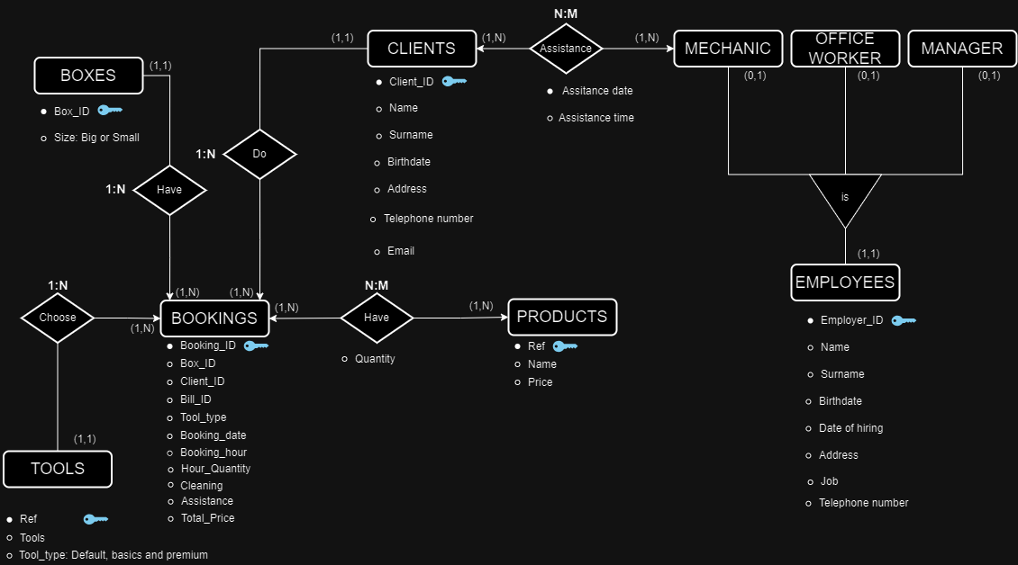

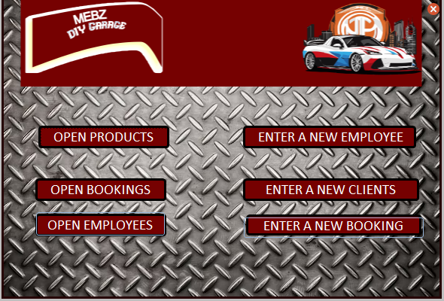

## MAIN MENU

When you open the Access the administrator and mechanics will see a basic menu, made with a macro, to navigate between the different forms and reports, also it has a button to exit the application.

When you open any of the left side options it will show the reports of employees , bookings and products tables. Here you can find the same register as the tables but in a better visual way and also the have their representative buttons to go to the main menu:

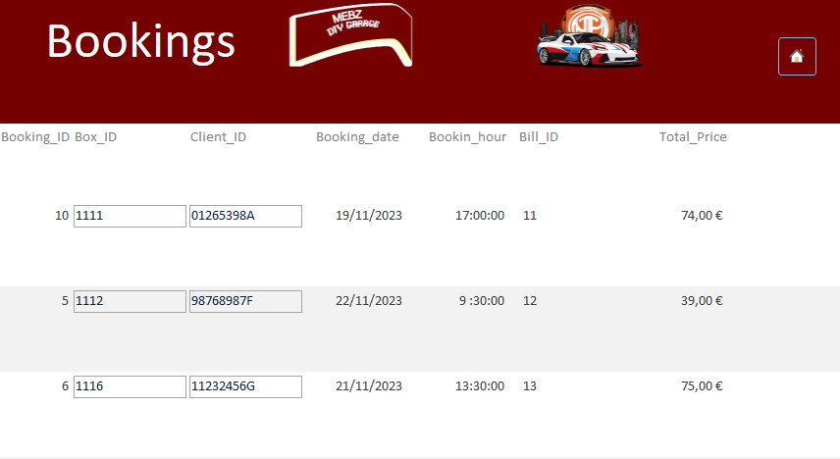

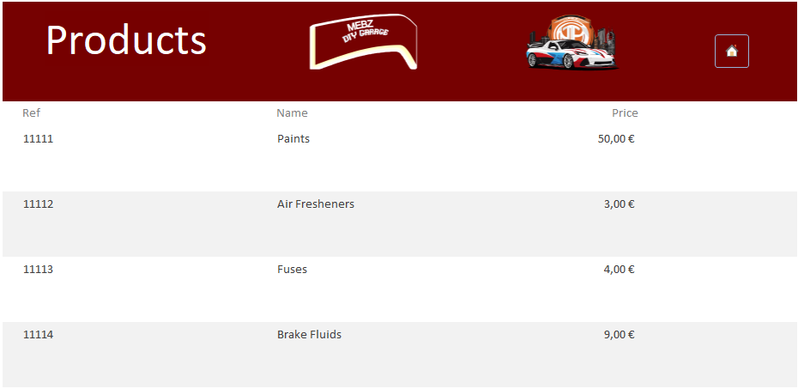

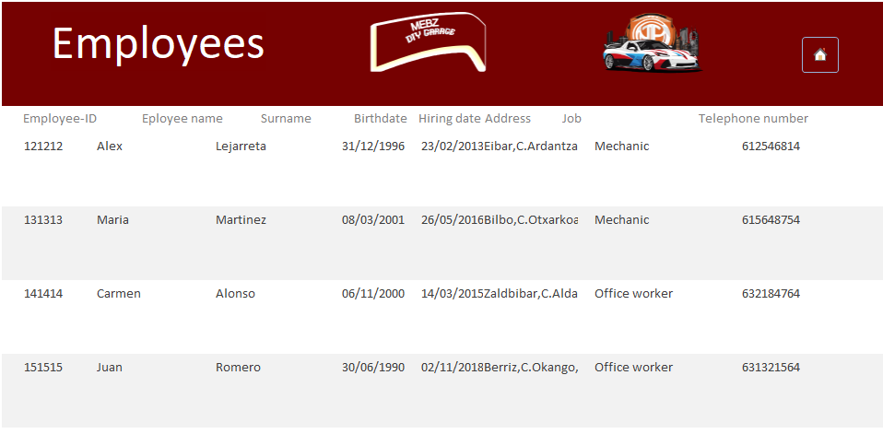

Whereas in the right side you will find the forms, in those forms you can see the registers and navigate from one to other with buttons and as the reports you will have the buttons to return to the main menu. In this forms besides see the registers you can enter new ones and automatically will be added to the respective tables. This are the forms:

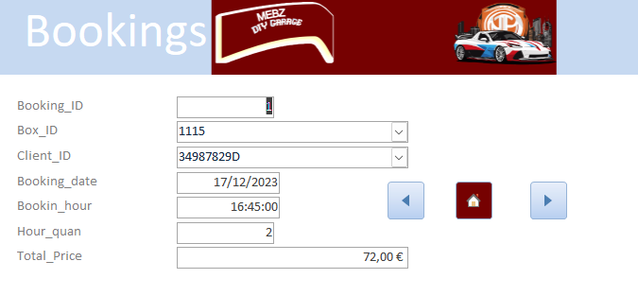

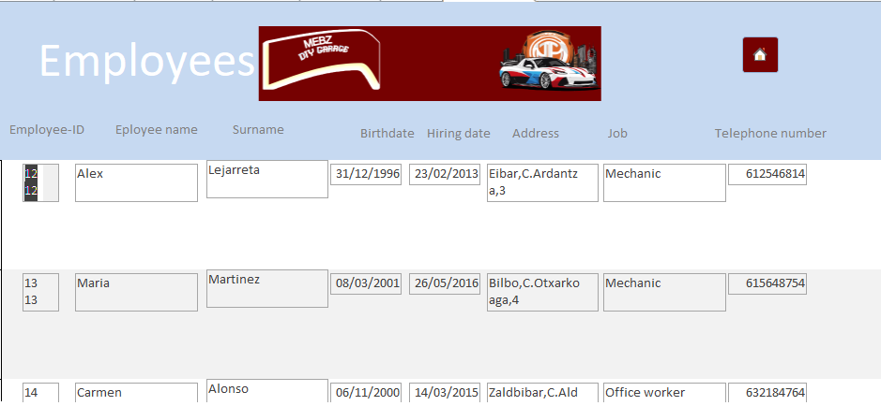

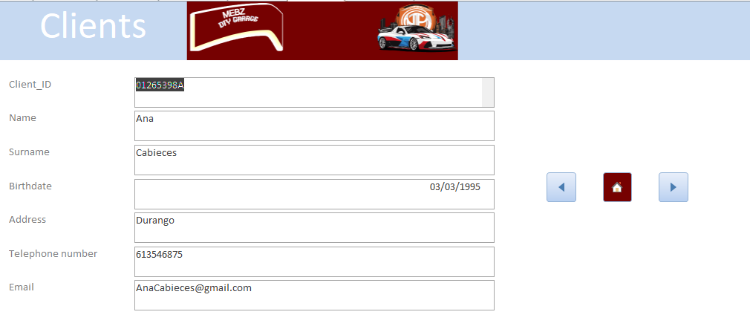

## TABLES AND REGISTER

## This are the tables and the information that they save:

## 

## 

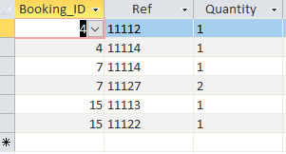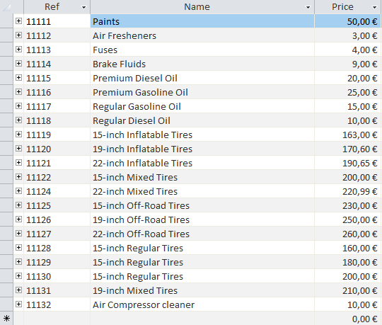

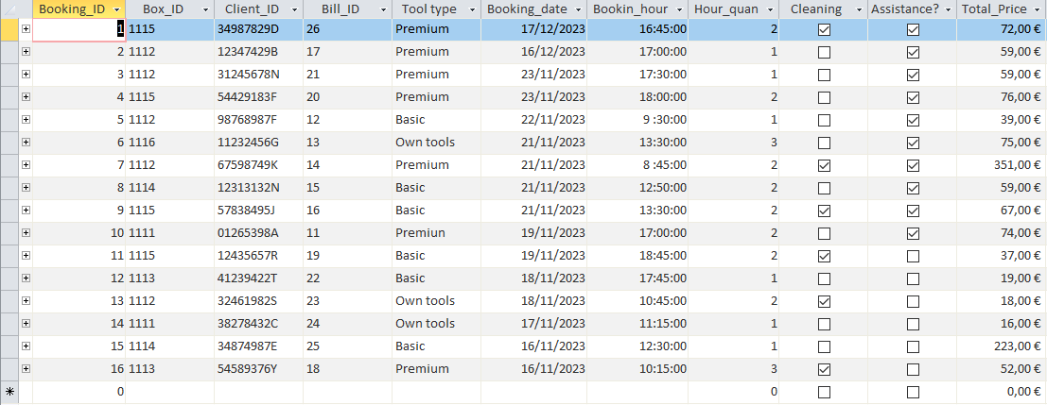

## QUERYS

We made some queries to find things more easily or to take into account how many bookings are in one day.

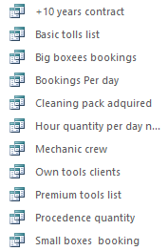

This is the list of the queries, the first query is for the employees in our business who have worked for more than 10 years because they gain a plus money in the payroll and also the query for only the mechanic Crews table.

Then we have an exclusive basic tools list and we have the same for the premium tools list and the own tools list,

For bookings we have different queries first for the box bookings we have two different tables one for the big ones and another for the small ones. Then we have the information of the people who book the cleaning pack.

The last ones are to count how many books were in a day ,how many hours were in novembers booked and the last one to know from where the people come to the garage

# C MENU

## INTRODUCTION

Our C menu is designed for the employees that work in our offices. The program offers a range of functionalities, including calculating service prices, managing employee salaries, visualizing and changing prices, and even provides a set of entertaining games.

## 

## 

## STRUCTURE

The program is created with some “switch” structures to make it easier to choose the different options. inside of these “Switches” we have created others to break down the options for each of the functionalities. For example, in the option “Change prices” there is another menu to choose the price that you want to modify.

The main variables are created and initialized in the main program, but there are others that are created in the middle of the program for a specific use. Internally, we use some functions in the first lines of the code, outside of the main part. We did that to organize the program better and be clear when making changes.

## FUNCTIONS

We use different functions to enhance the clarity of the program. Some of them are designed to simplify the equations used to calculate prices. This allows us to write the complex calculations within the functions and keep the main program clearer.

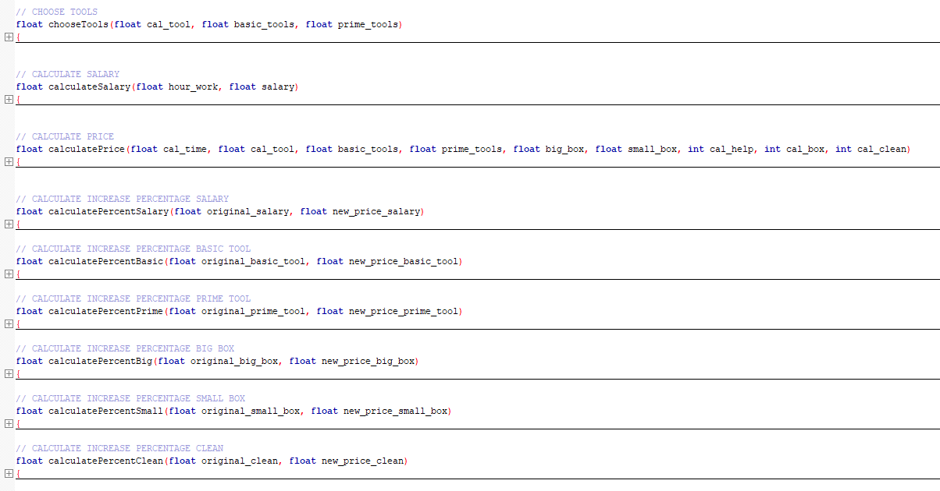

### 

### FUNCTIONALITIES

At the main menu we have six different functions: “Exit, Calculate the price, Calculate the salary, Visualize prices, Change prices and Games”.

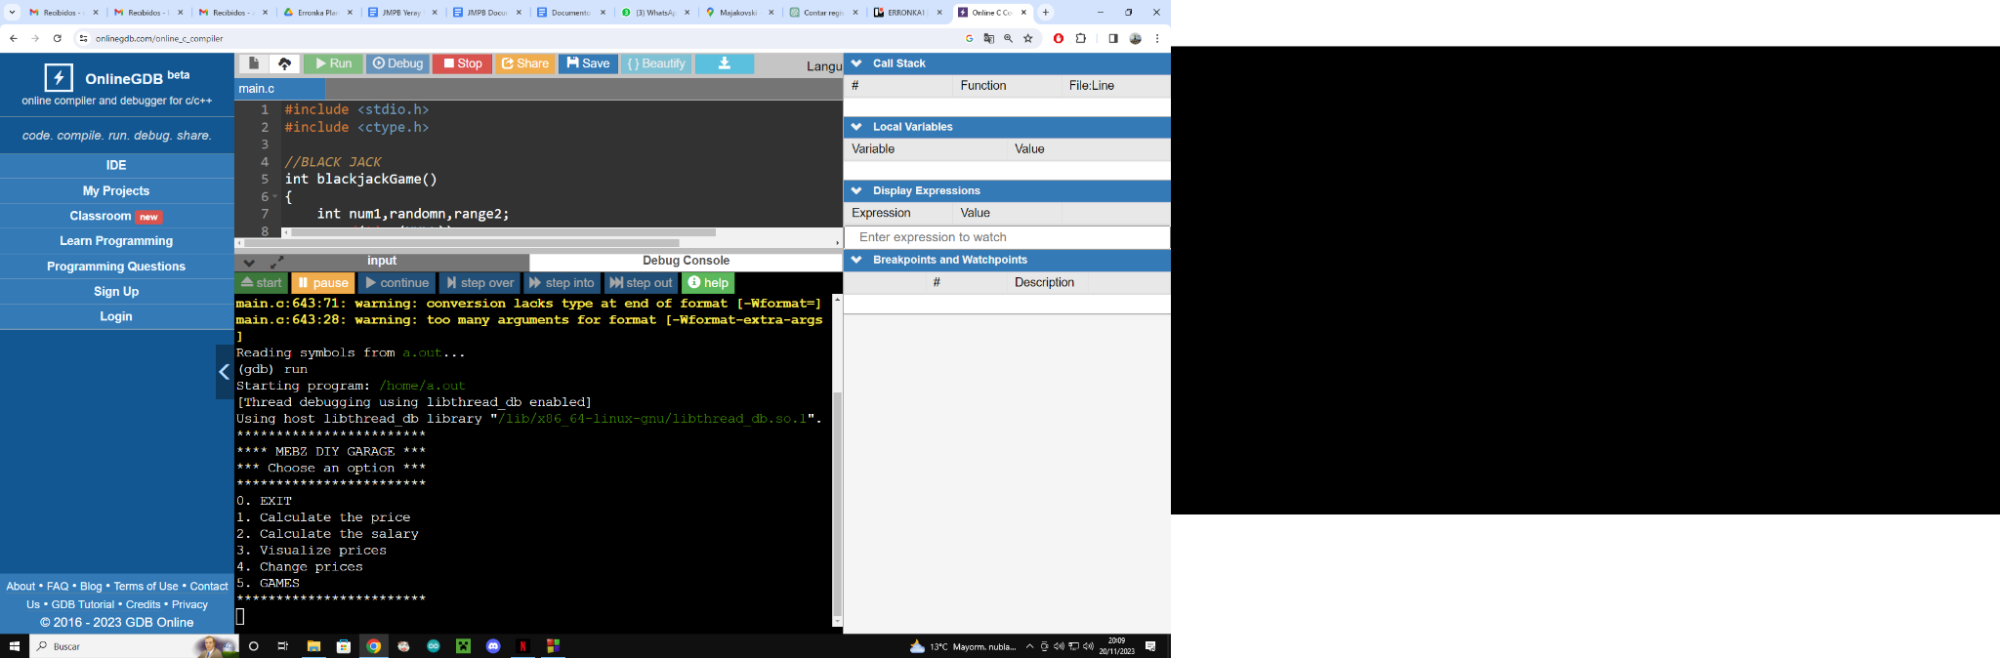

**0.Exit:** The function is the number 0 to be able to expand the program without modifying the program in excess.

**1.Calculate the price:** The program asks some questions to the user to calculate the bill for the client.

**2.Calculate the salary:** This functionality is designed to calculate the salary of an employee based on the number of hours worked and the monthly salary.

**3.Visualize prices:** This option provides a clear and organized display of the current prices for various services, including box rentals, tool packs, cleaning services, and employee salaries. It offers transparency to the users about the existing pricing structure.

**4.Change prices:** This functionality allows users to modify prices based on specific needs or market conditions. The program guides the user through a submenu where they can choose the type of price they want to change, such as box rentals, tool packs, cleaning services, or employee salaries.

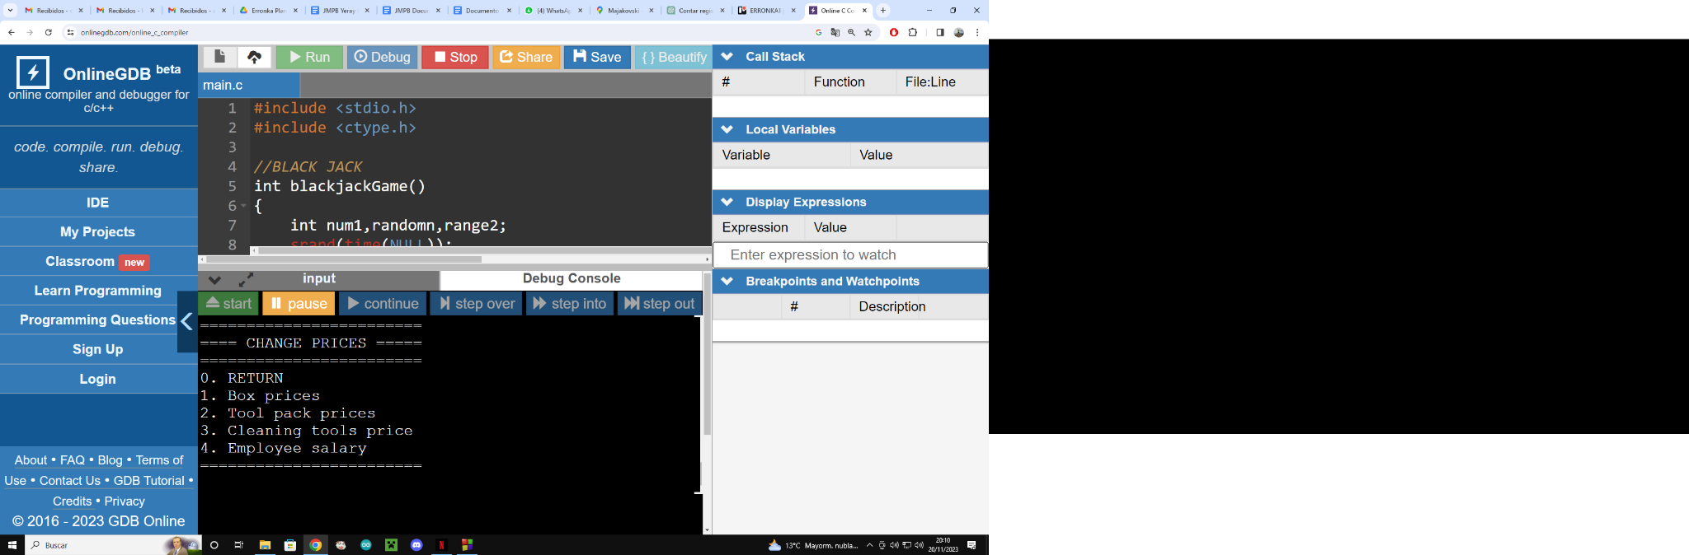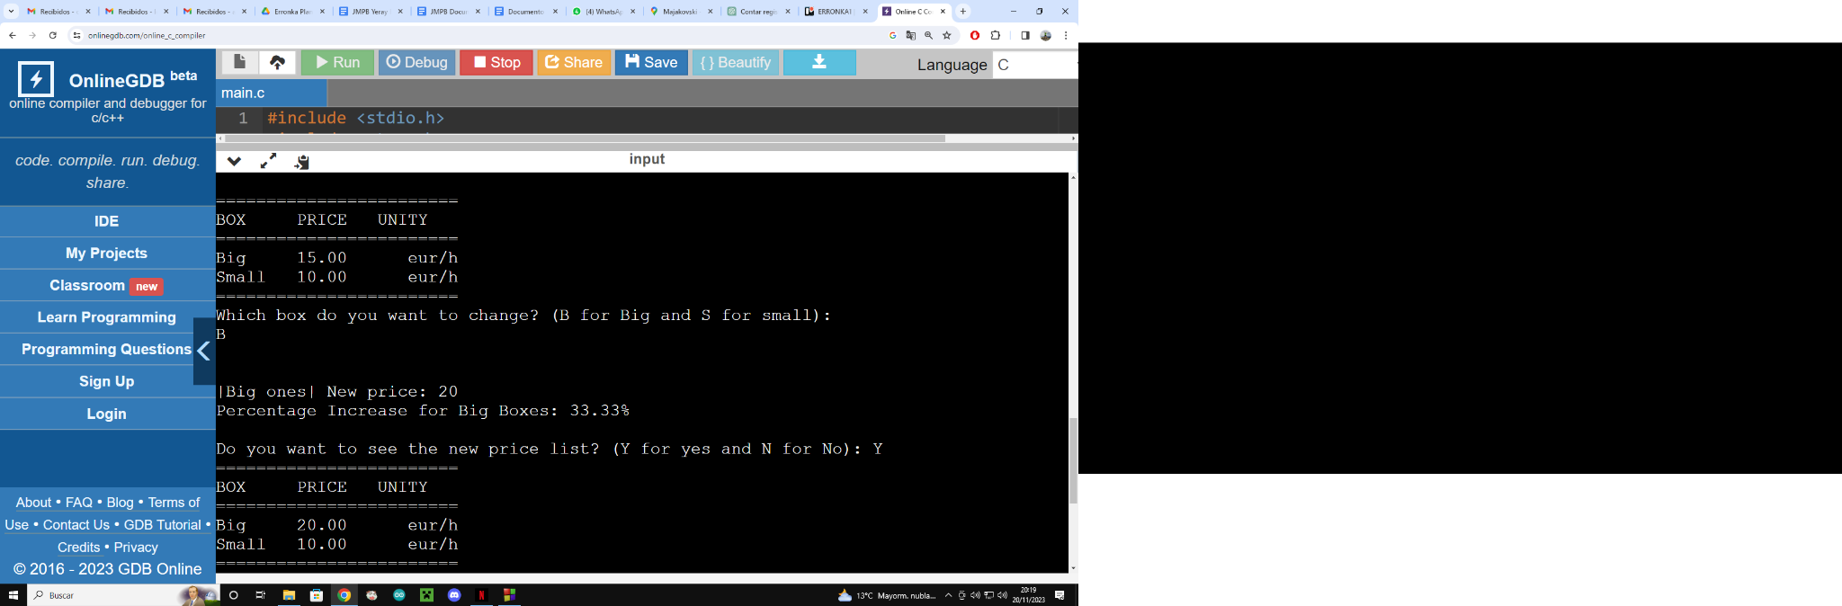

**5.Games:** The program offers a set of entertaining games to provide a recreational break for the users. The games include Blackjack, a rhombus pattern game, a number-guessing game, and a pyramid-building game.

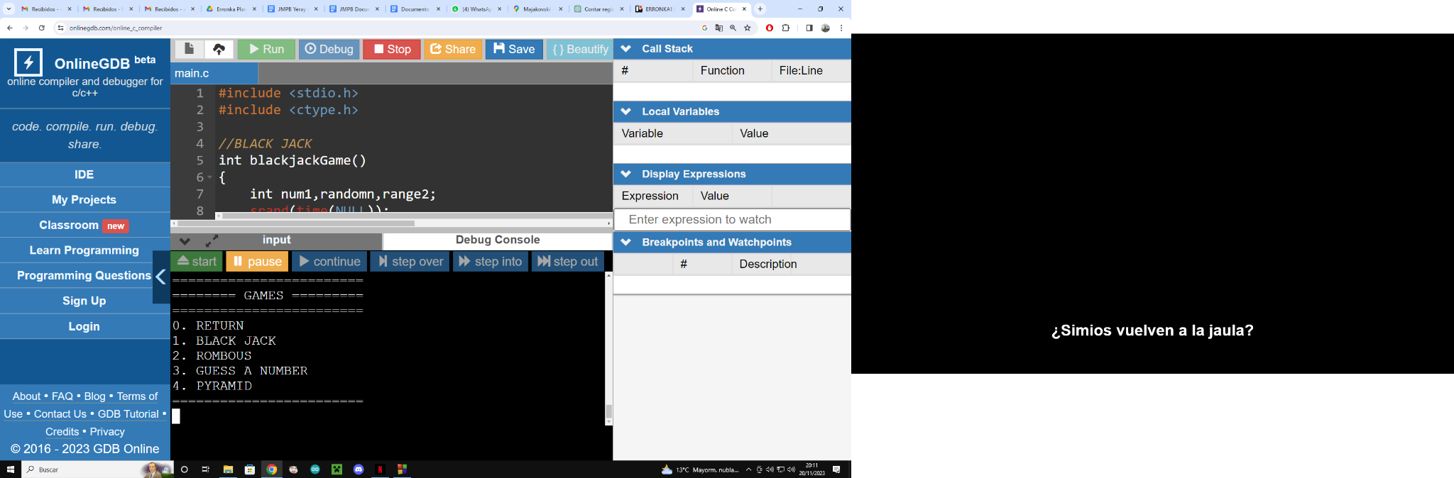

# 

# 

# 

# WEB PAGE

All the programs were divided by DIVs and also the location was set with floats ,margin and padding , also they follow the same estrcuture : at the top we have the header with the language selector where you can select between Euskera, Español and English. Below that part we can find the navigation side ,with the logo of our company and the nav to select the pages. Then we have the article where the content of the pages is and each page is different. At the bottom we have the last part of the side,the footer that is going to variate into three formats the contact one with our social medias and the gmail ,the contact only with the gmail one and the blank one, every footer has a button to go at the top of the page.

The home page side in the article side we can find at the top a marquee which is an images loop of our garage, then we have a piece of information about the business and at the bottom we can find the location map and the booking to go to the booking page.

The facilities page the article appears a map of the place to find all the parts of the garage, then you can find all the descriptions of facilities of our garage.

The prices page is about the prices of our products and facilities which are accompanied with a picture of the product or facilities and their own price at the products side we added a link which redirects you to a whole list of products and their prices.

The bookings side we can find a form to fill ,which has all the required information so you can make a reservation.

The last page is the contact us page, here we have a form to fill in case the customer has any doubt to contact with us. At the right side we can find the location of the garage and the social medias and the gmail in case they want to come or follow us in our social medias.

## PHOTOS

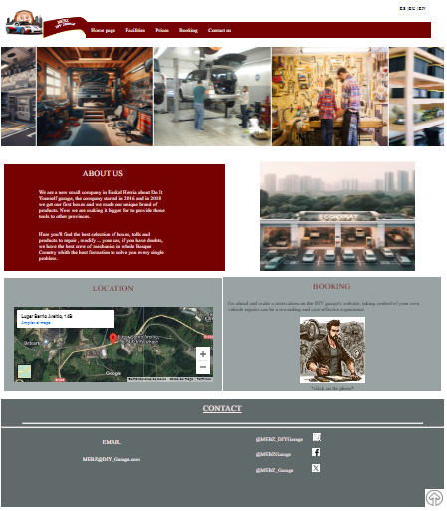

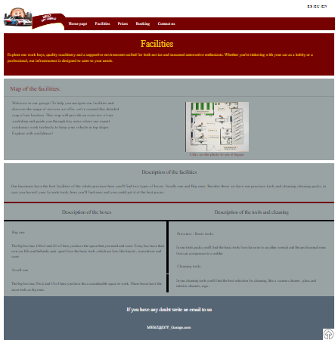

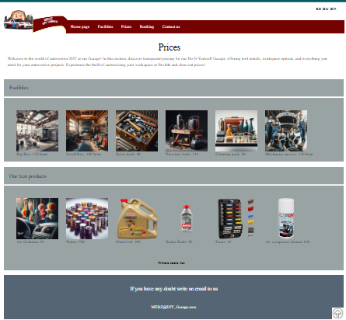

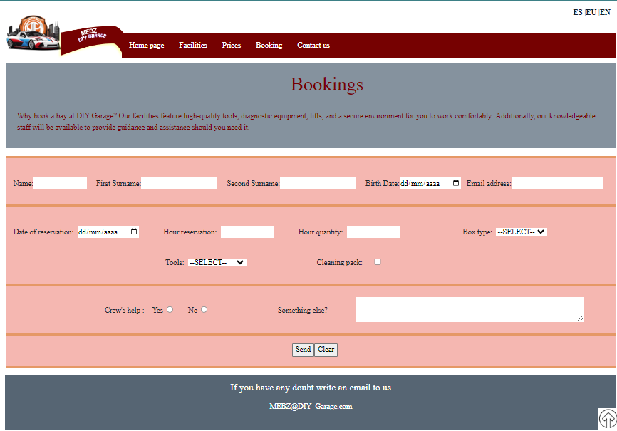

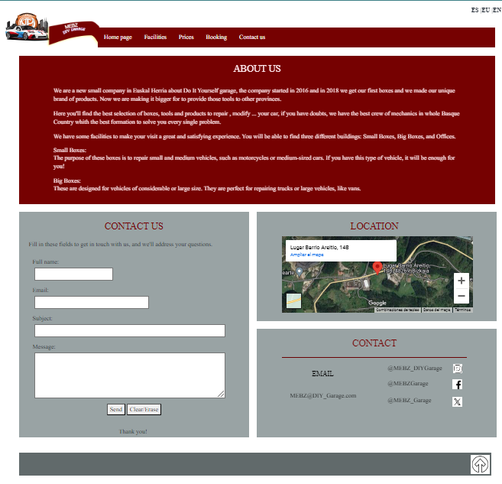

# 

# SYSTEMS

## HARDWARE

We plan to install on the PC of the MEBZ company windows 10 pro, we already have explained that is the best OS for the workers. The computers will have this hardware:

Asrock A520M-HVS

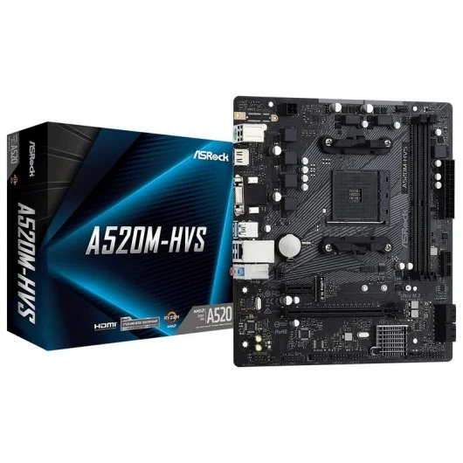

Aerocool CS-105 USB 3.0 Negra/Roja con Ventana

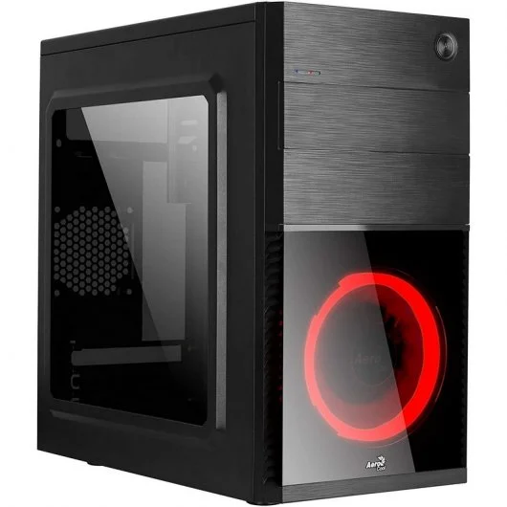

AMD Ryzen 5 3600 3.6GHz 32MB



Crucial CT16G4DFRA32A DDR4 3200Mhz PC4-25600 16GB CL22

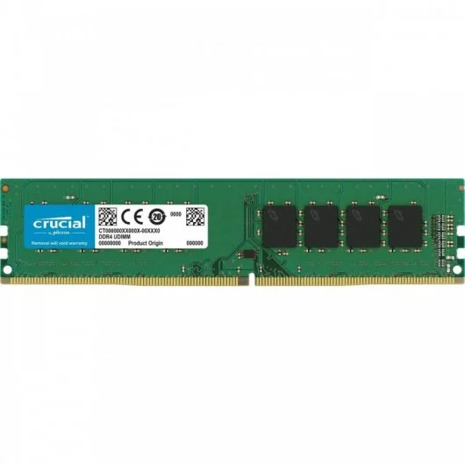

NOX Hummer Alpha 600W 80 Plus Bronce

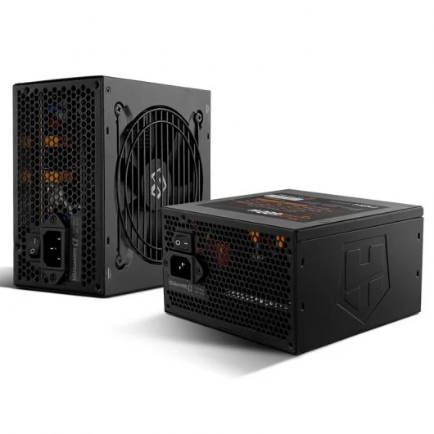

Samsung 870 QVO SSD 1TB SATA3

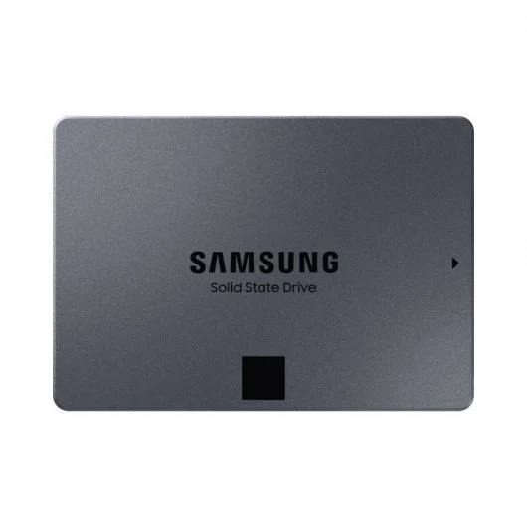

MSI AMD Radeon RX 6500 XT MECH 2X OC 4GB GDDR6

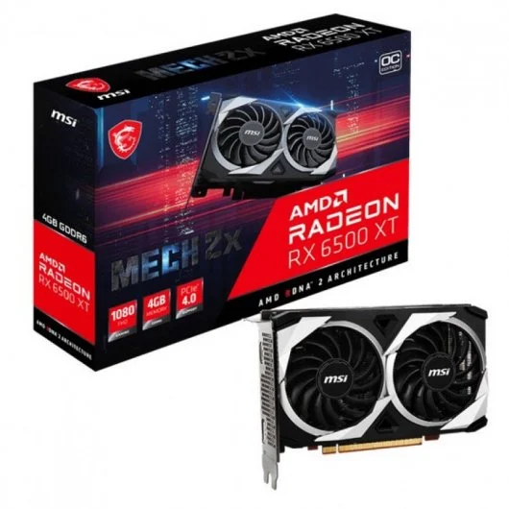

## VIRTUAL MACHINES

The first thing is to make a virtual machine

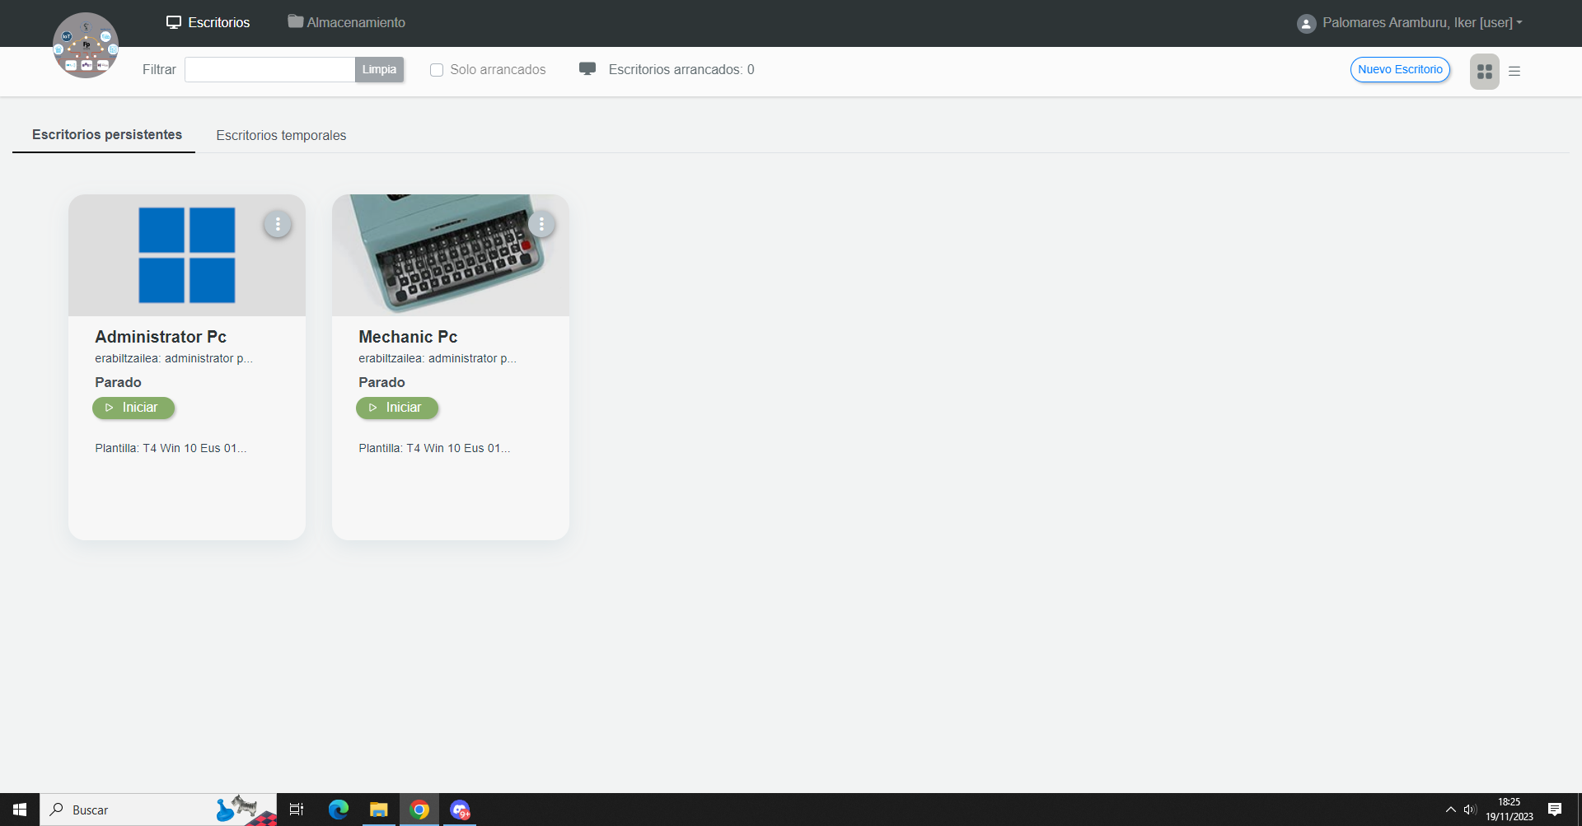



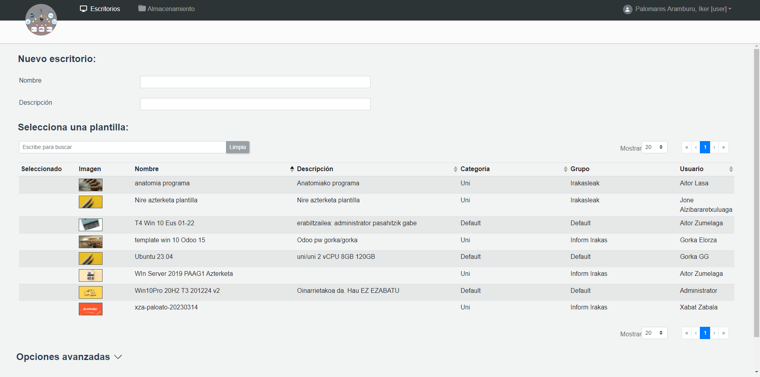

Find Windows options

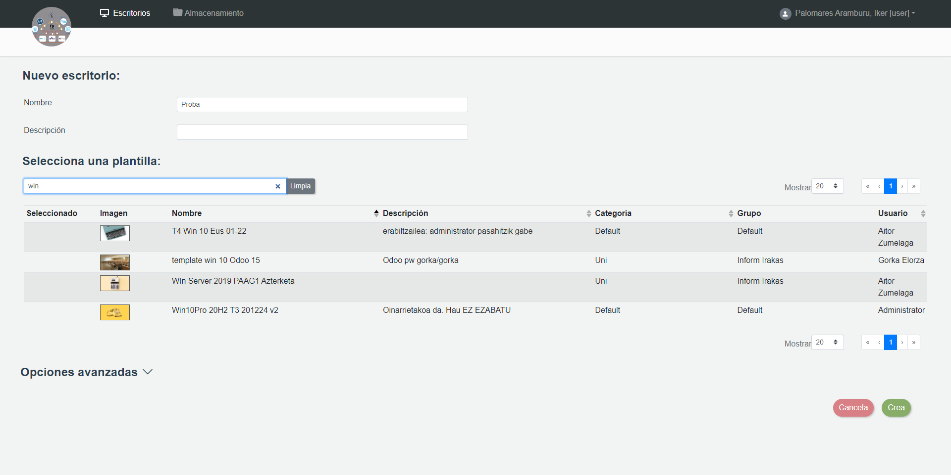

We will use the first one, select it and press crea

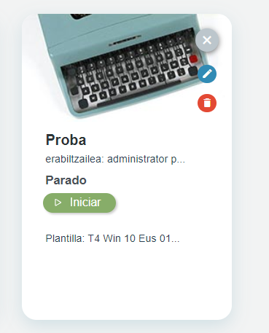

Here we edit with the pen





Here quit wireguard and put your team

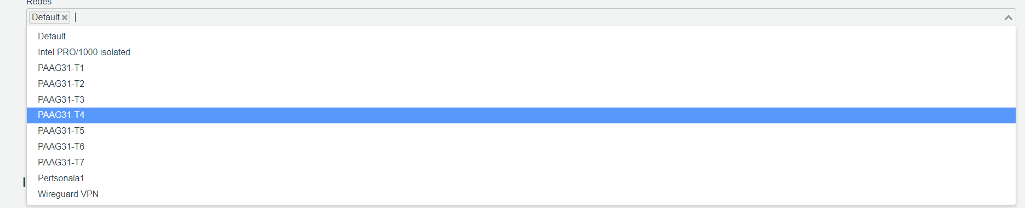

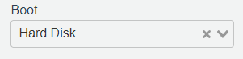

Remenber to change this to CD

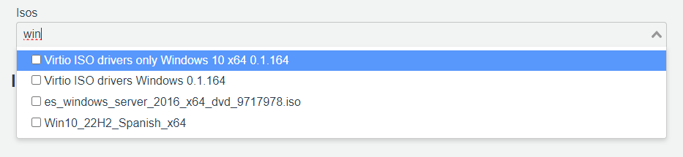

Here follow this order first operative system then drivers

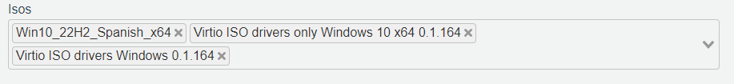

And to finish this part press envia

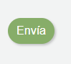

Press iniciar to start



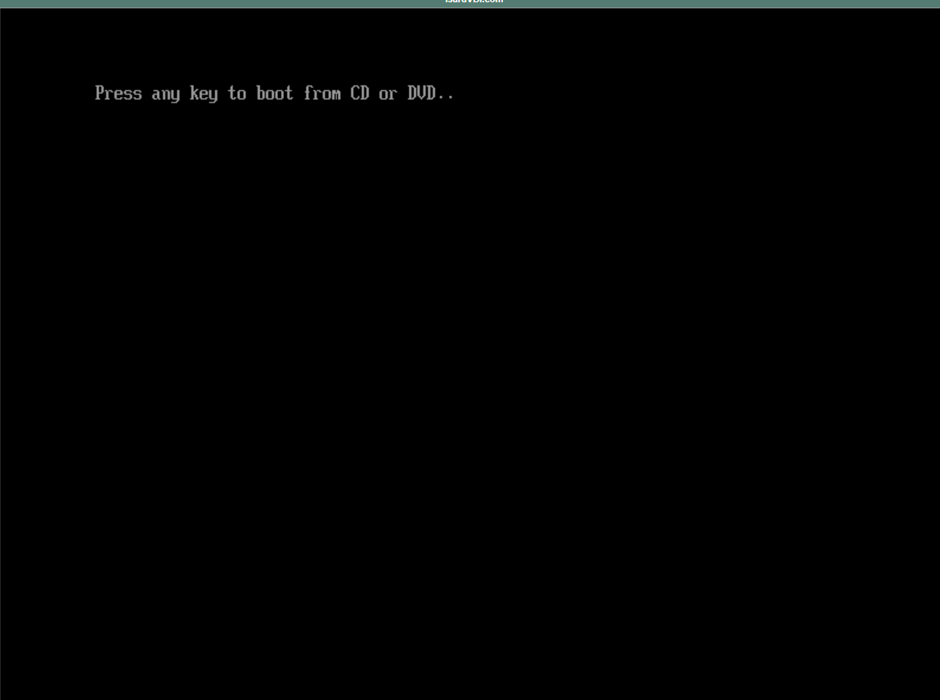

You have to enter fast in the machine and press any key otherwise it will restart

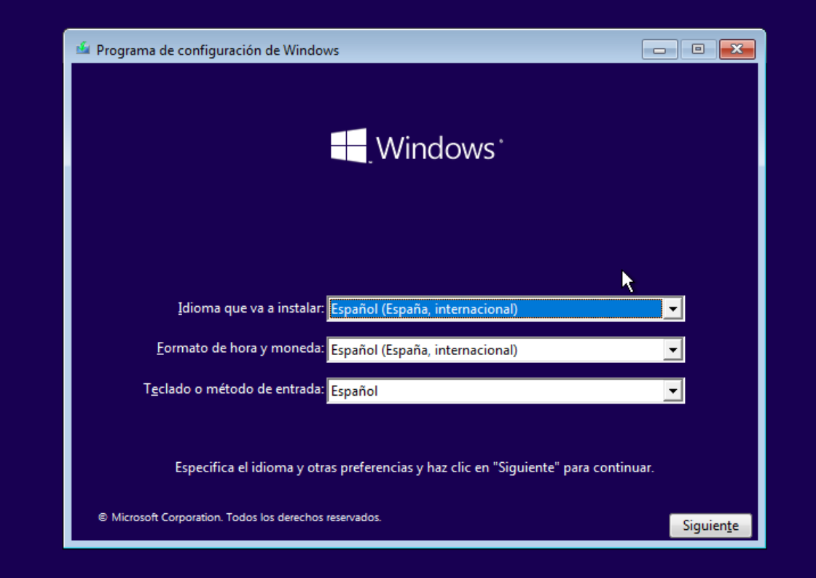

Press siguiente and then instalar ahora

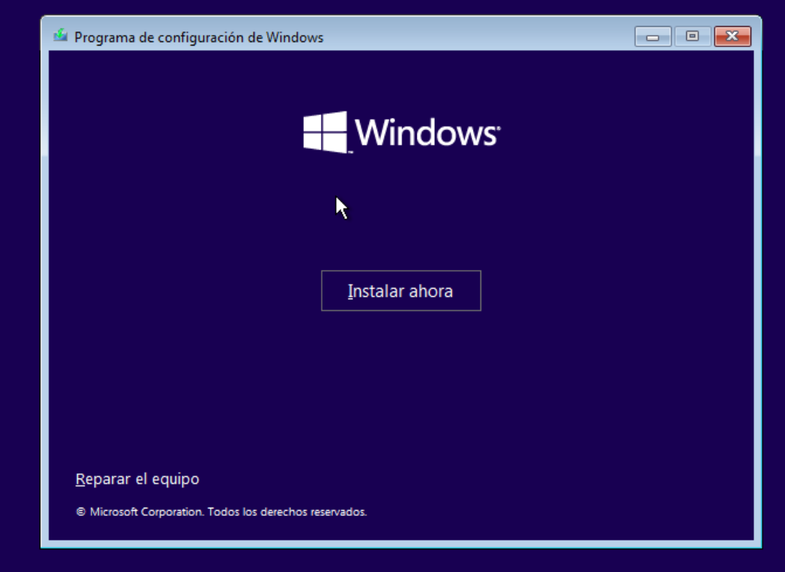

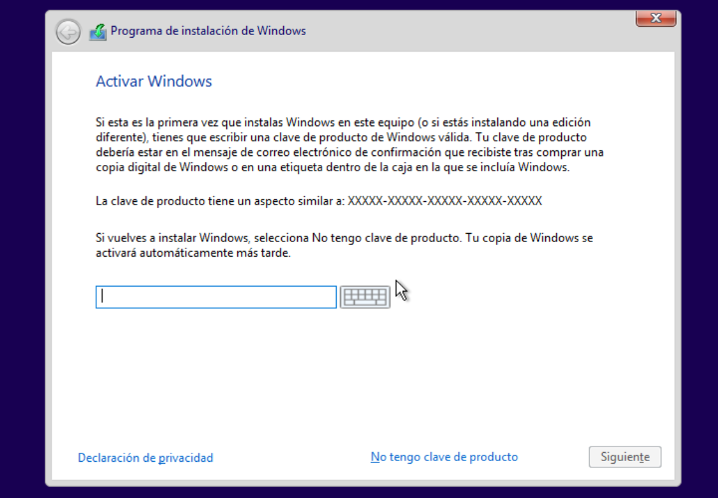

Press “No tengo clave de producto”

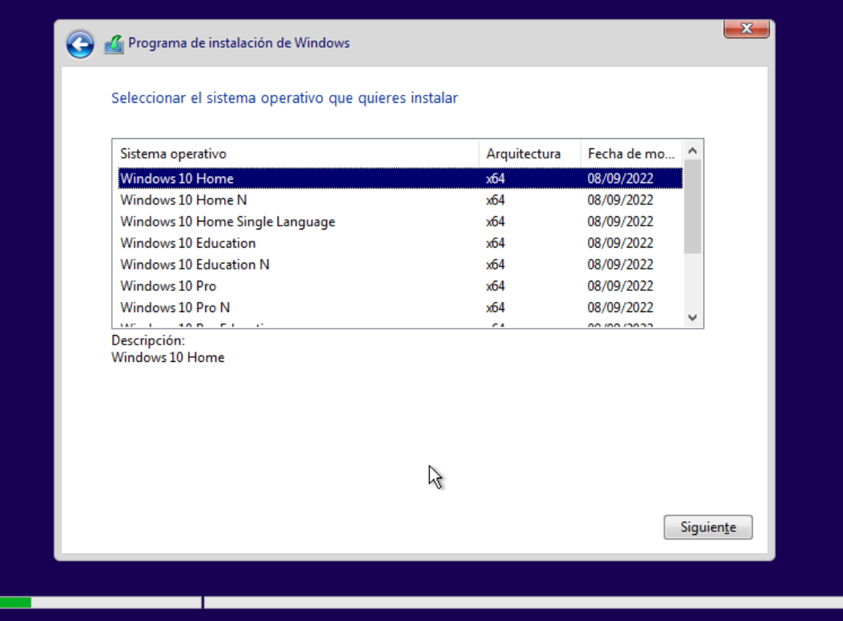

We will use windows 10 pro

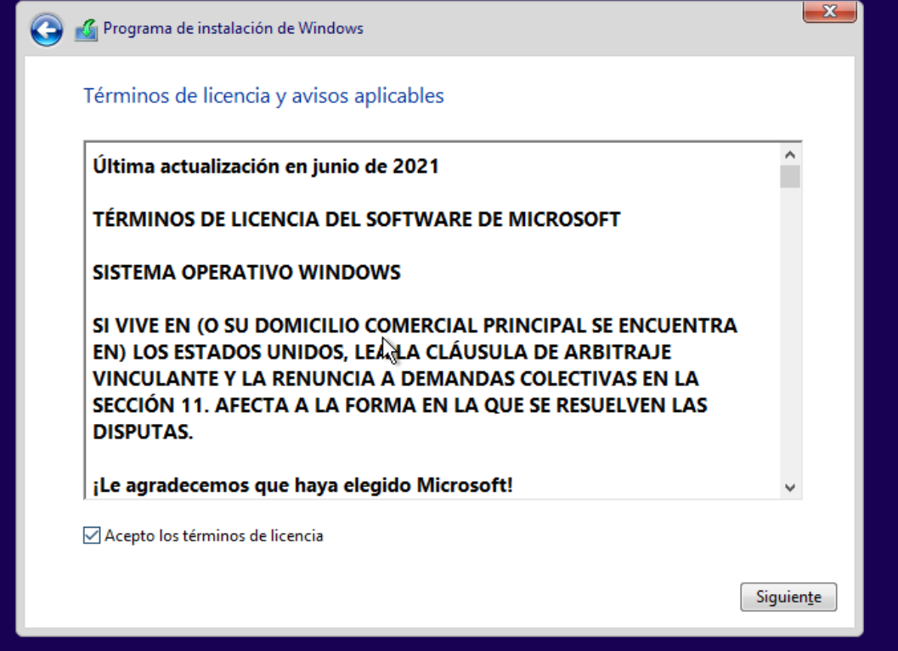

Press siguiente

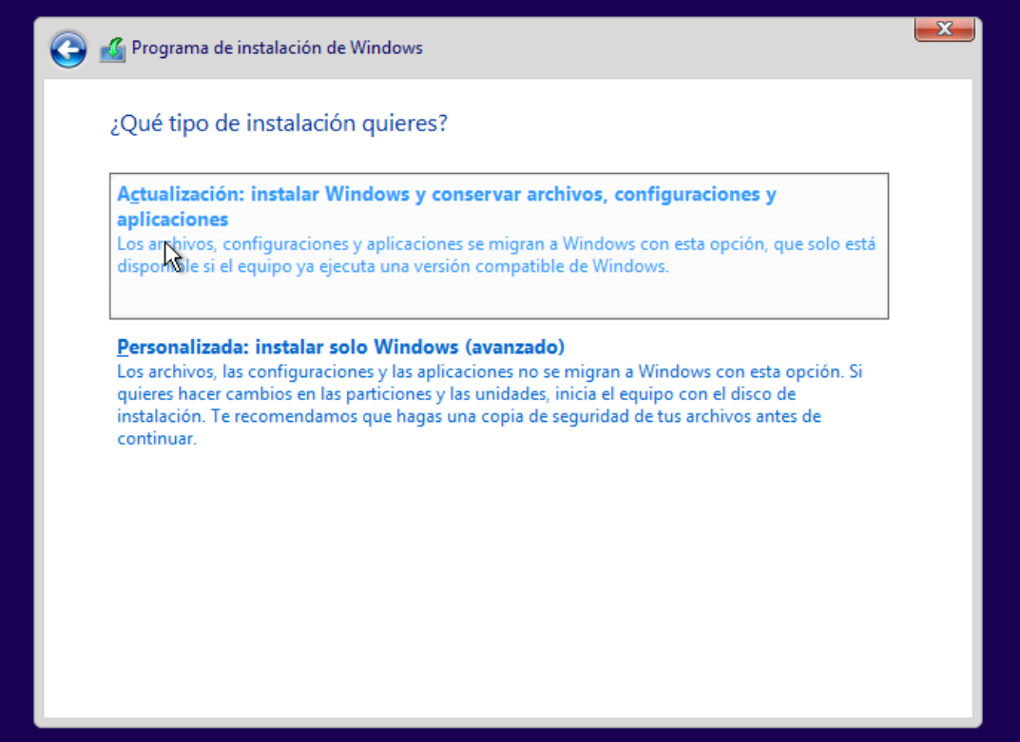

Press personalizada

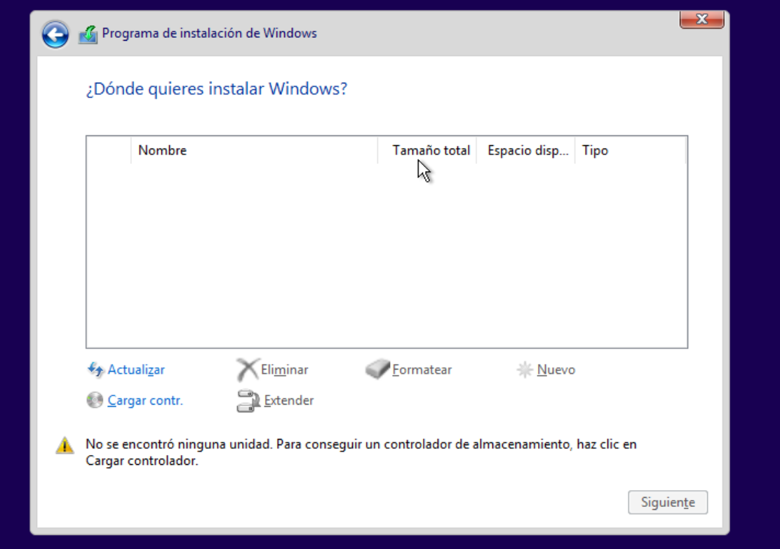

Press cargar contr.

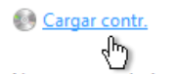

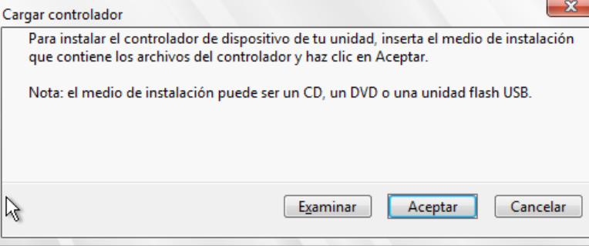

Press examinar

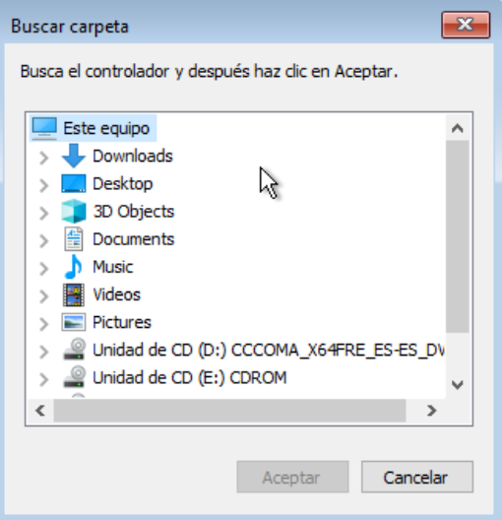

It will appear this



Inside that



Press this

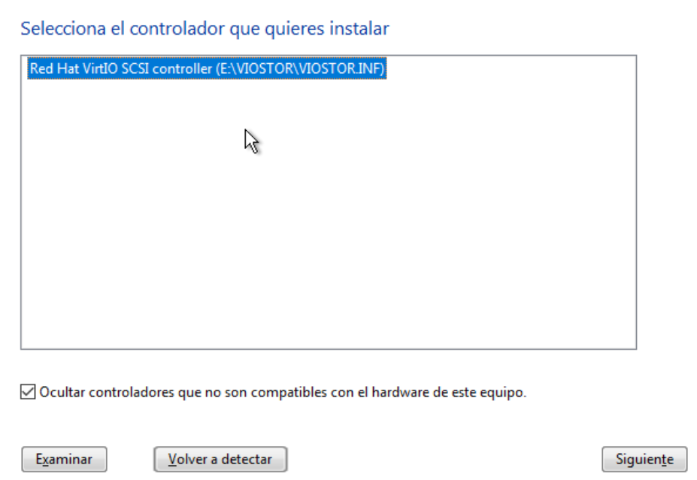

It will be like this and press siguiente

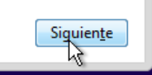

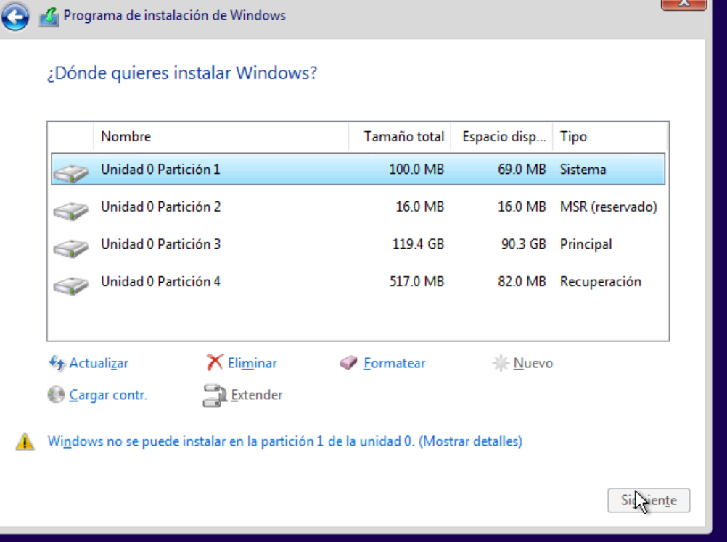

Here we can see the partitions, we can left the partitions like that or make new ones

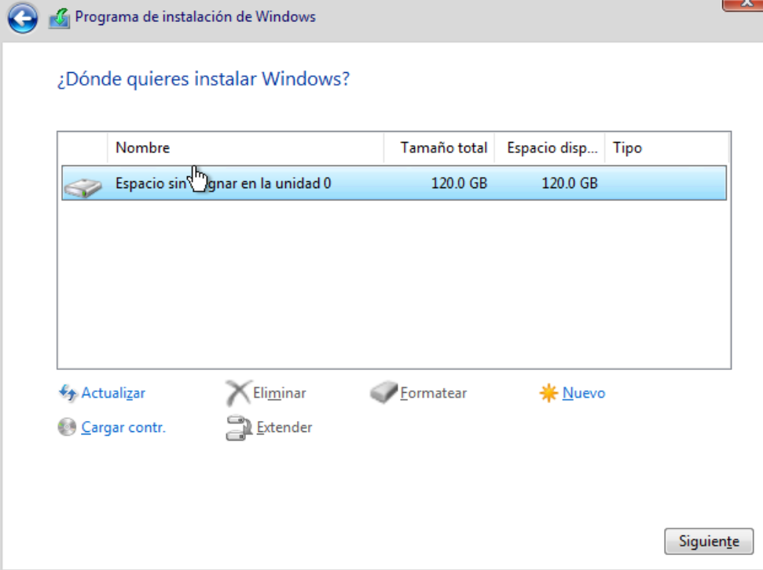

After erasing everything we will press nuevo and make new partitions

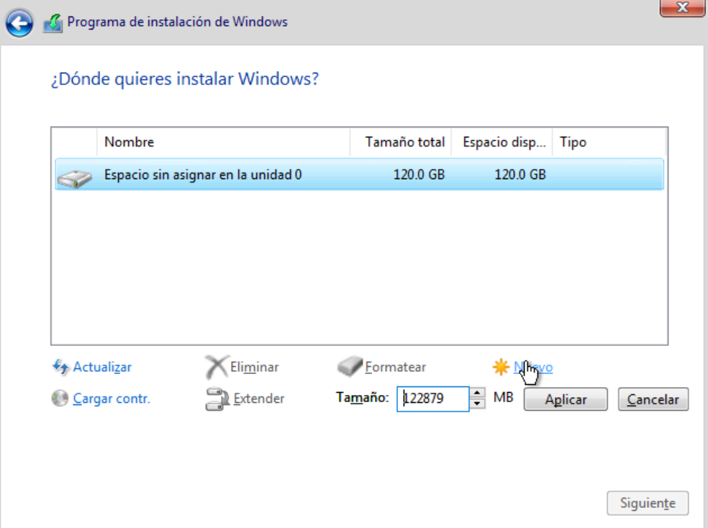

We will choose 80 GB for the windows partition

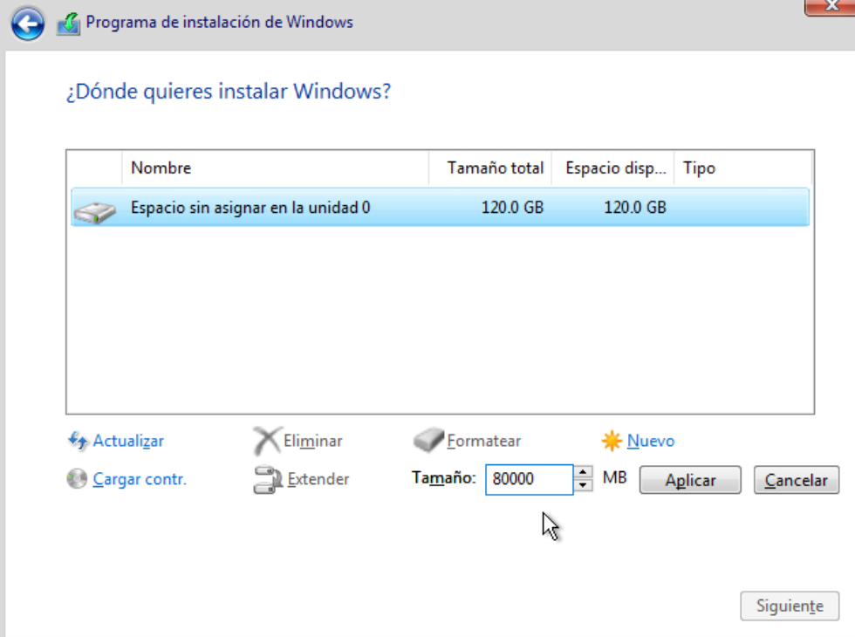

Horrela geratuko da

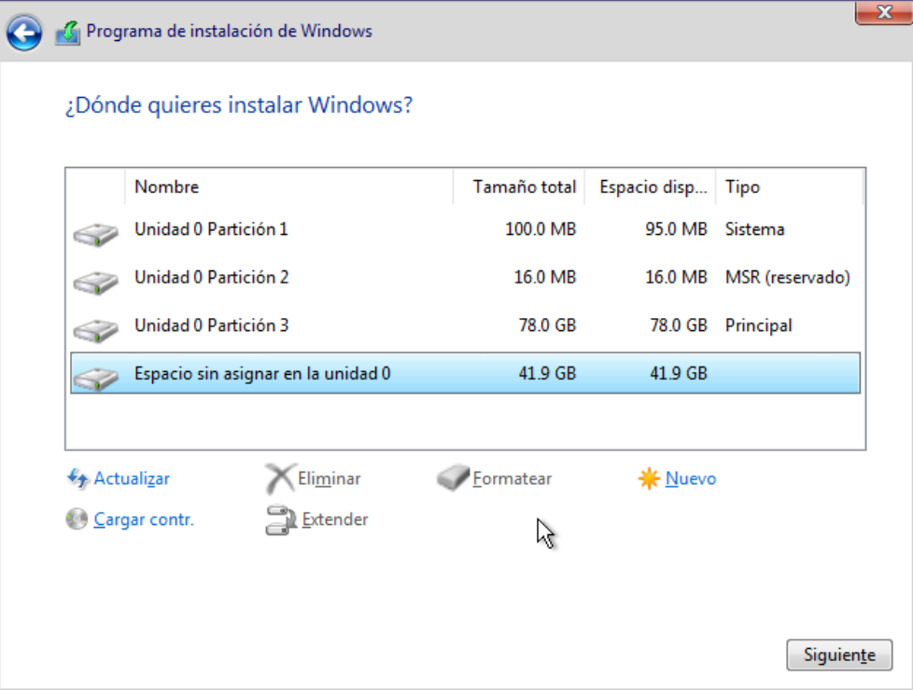

Here we press nuevo again

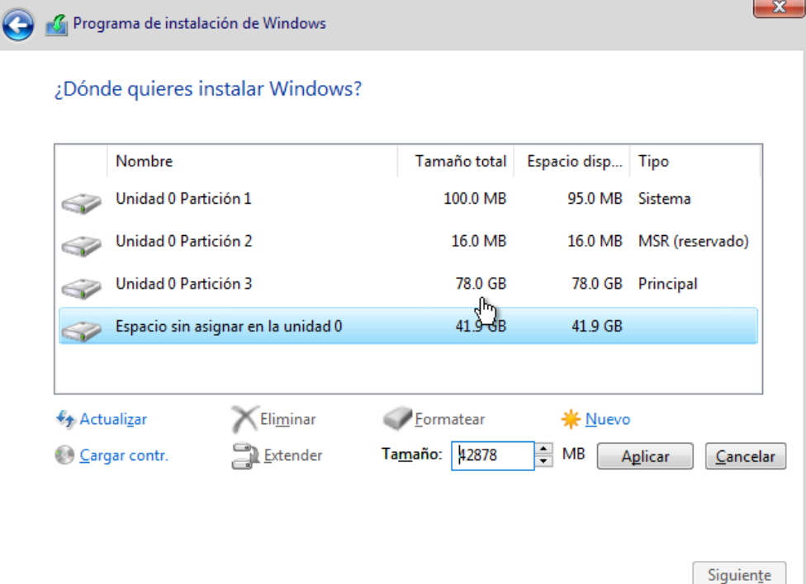

and then aplicar

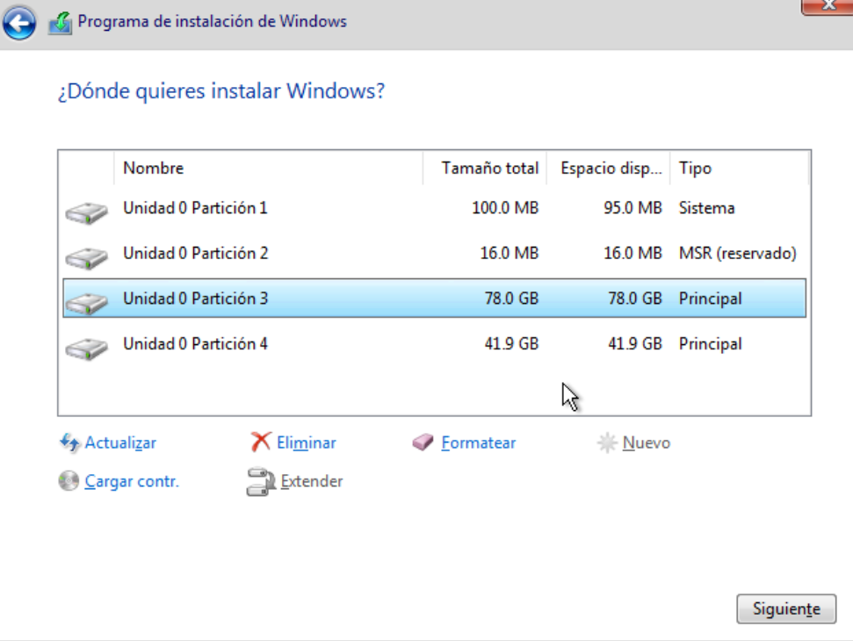

we choose the biggest partition for installing windows so click 3 and then siguiente

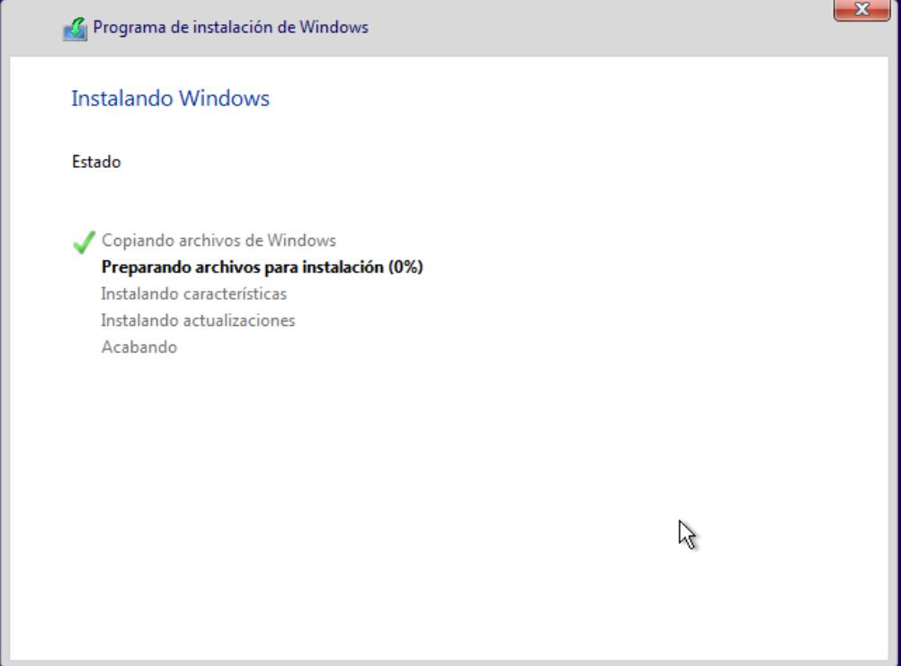

you will get this screen and then the virtual machine will restart, so we have to closethe machine

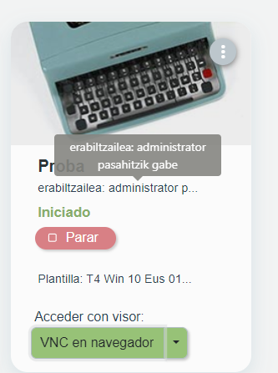

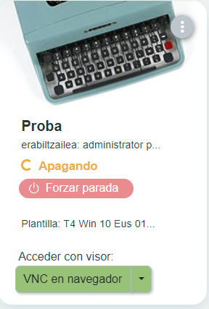

And now we edit the boot

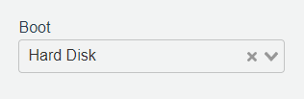

We change it from cd back to hard disk and restart the machine

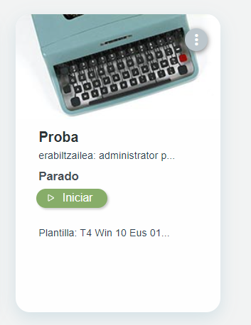

Now we have to install windows

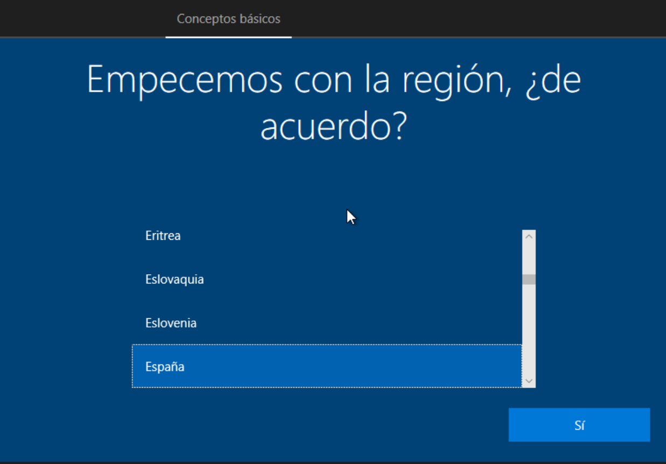

Choose the option that you prefer we choose this

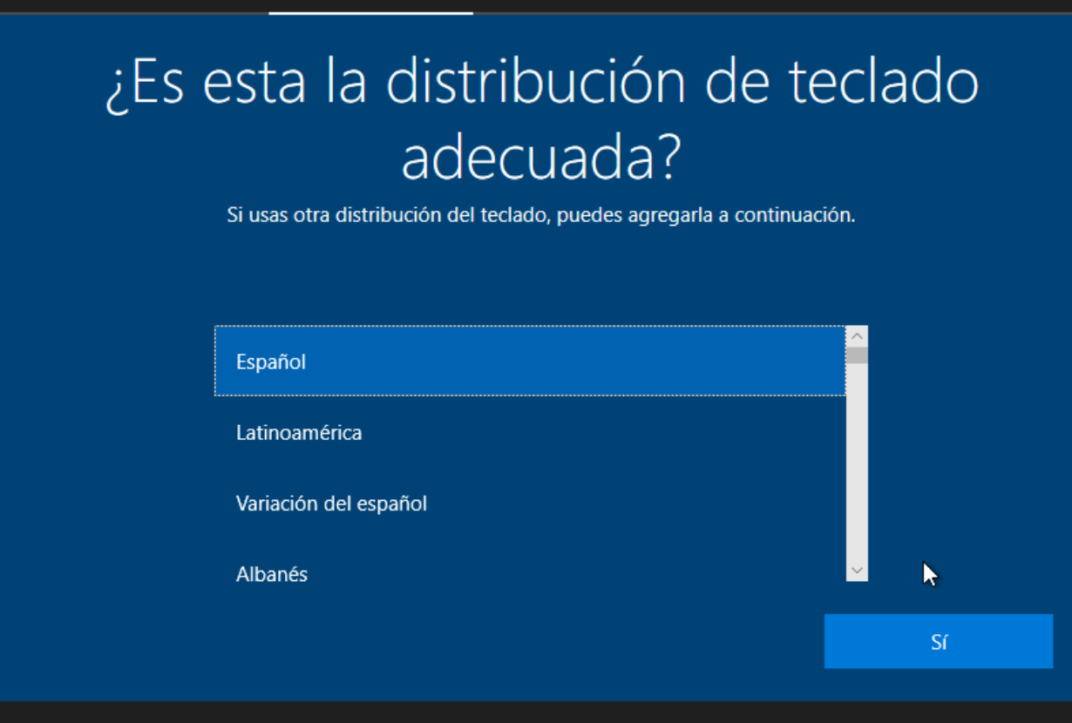

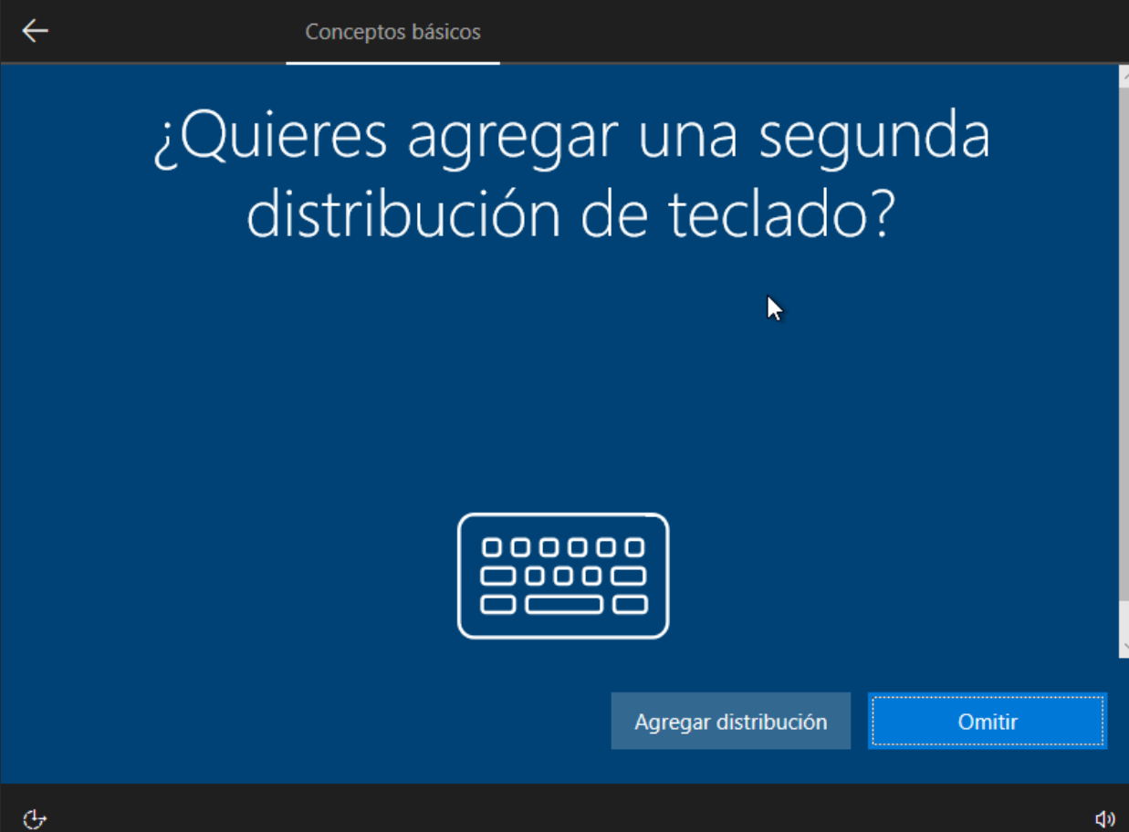

Here we press Omitir

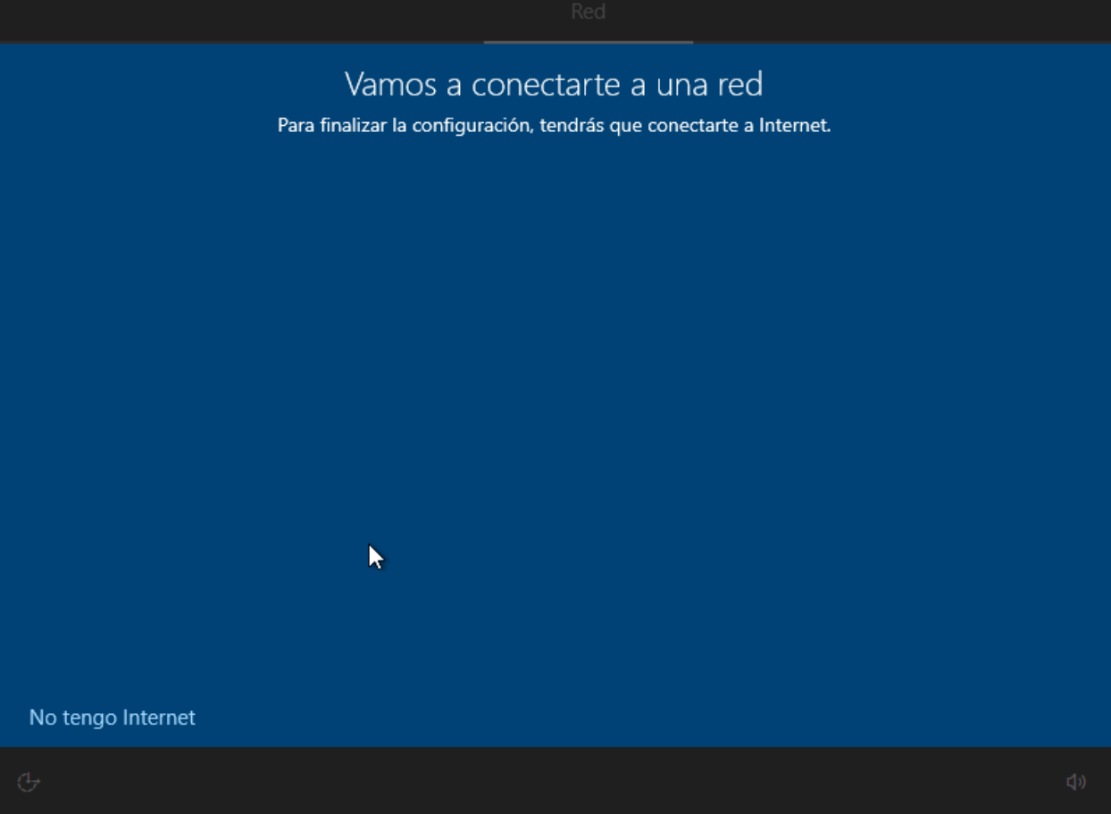

We press no tengo internet

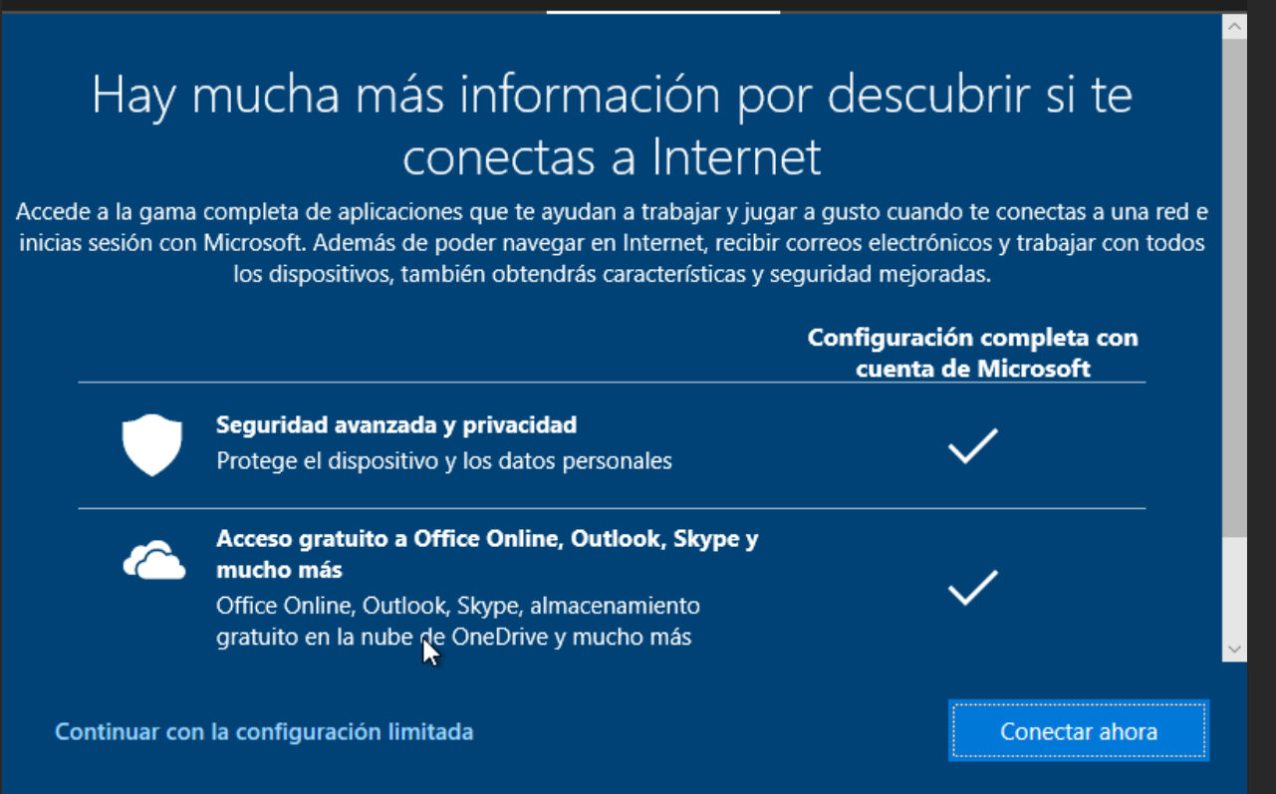

Here continuar con la configuración limitada

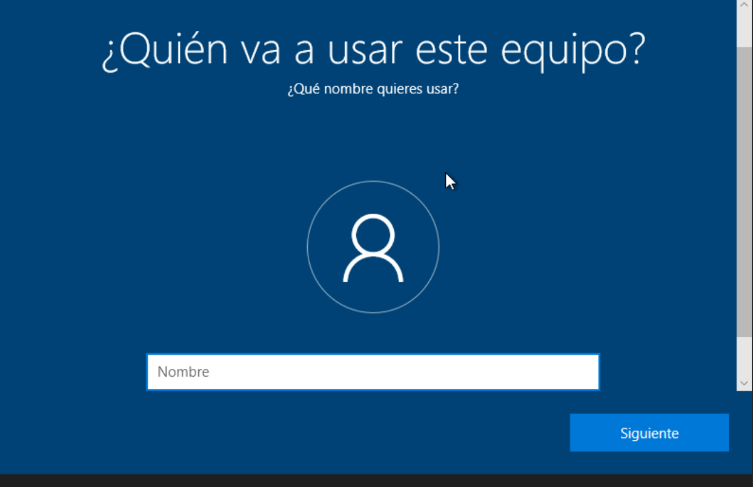

Enter the name of the user

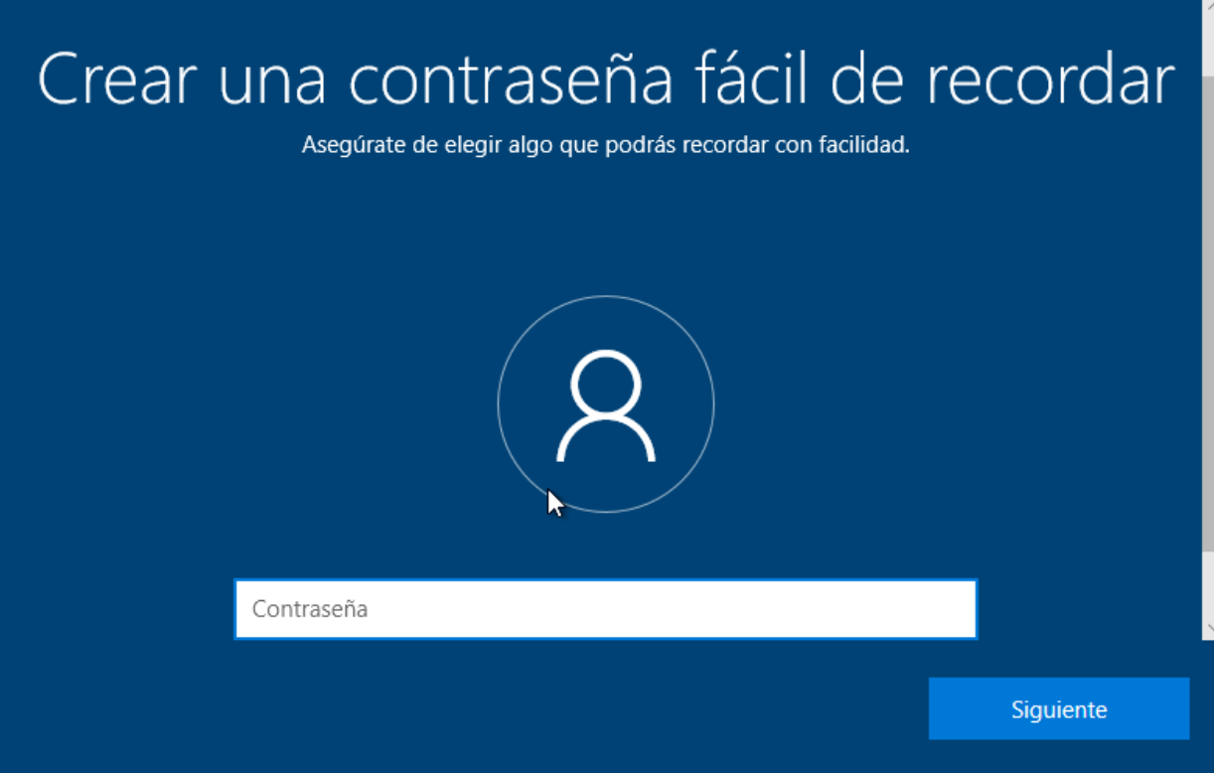

Here the password and then re enter the same password when you are asked

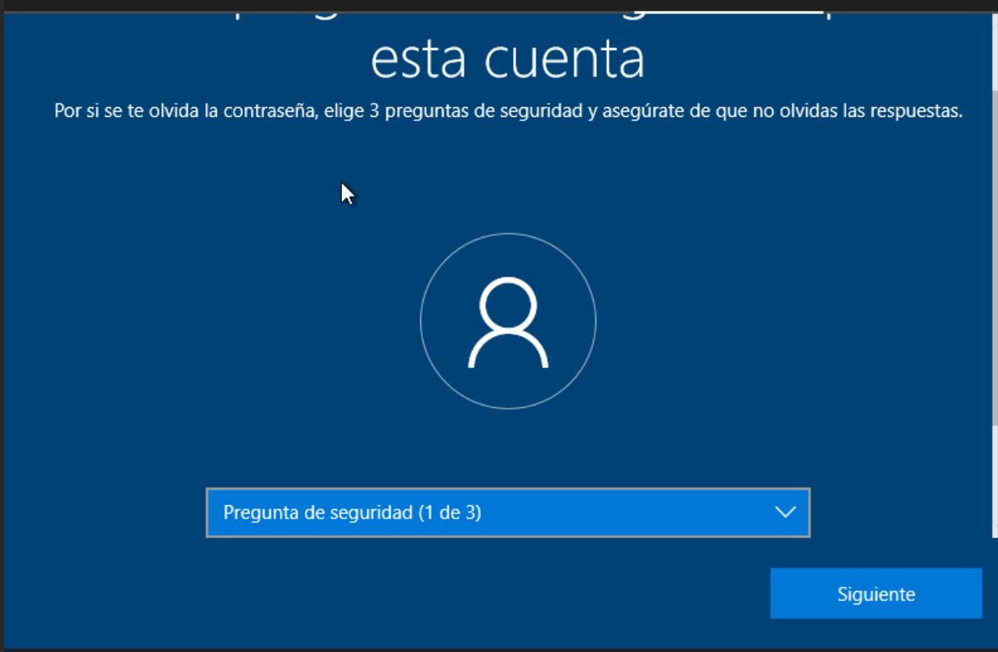

Here you choose the security question and answers

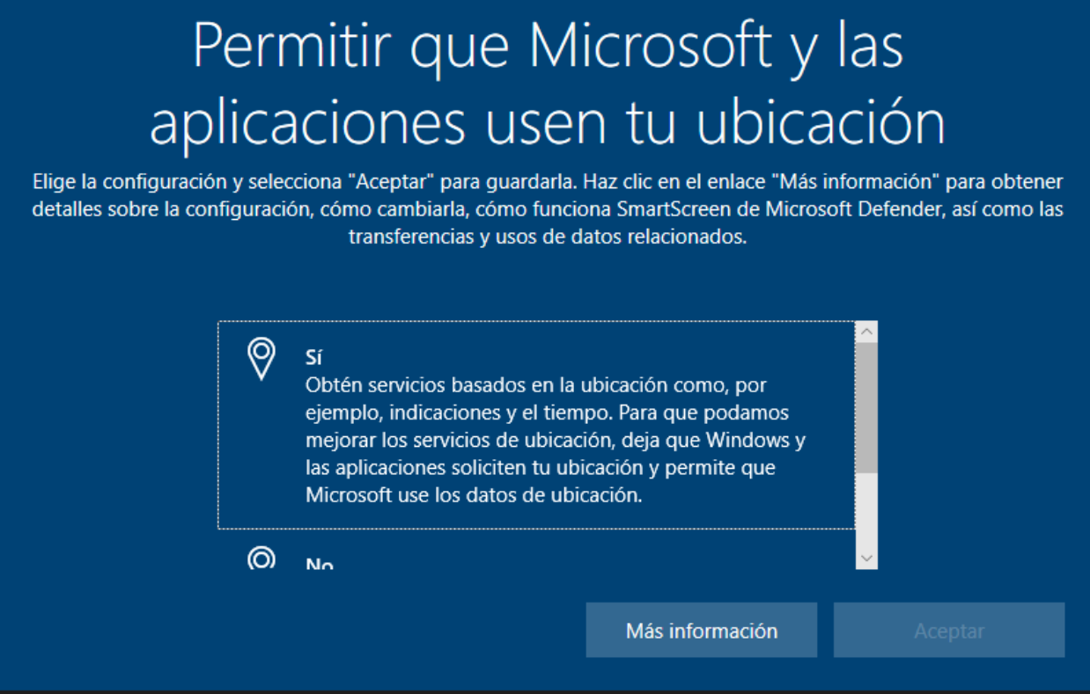

This option and the next ones better if you choose no or the less intrusive option

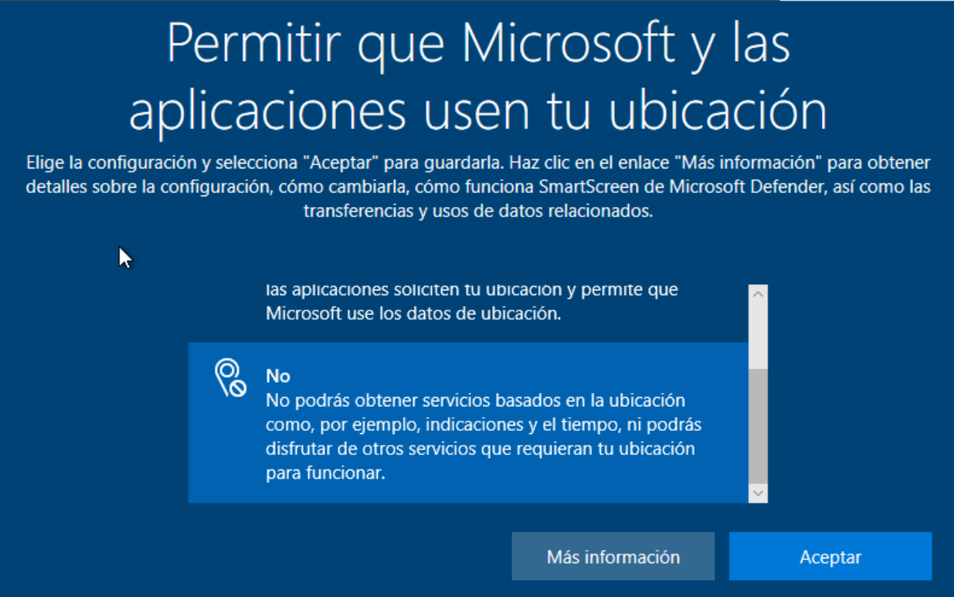

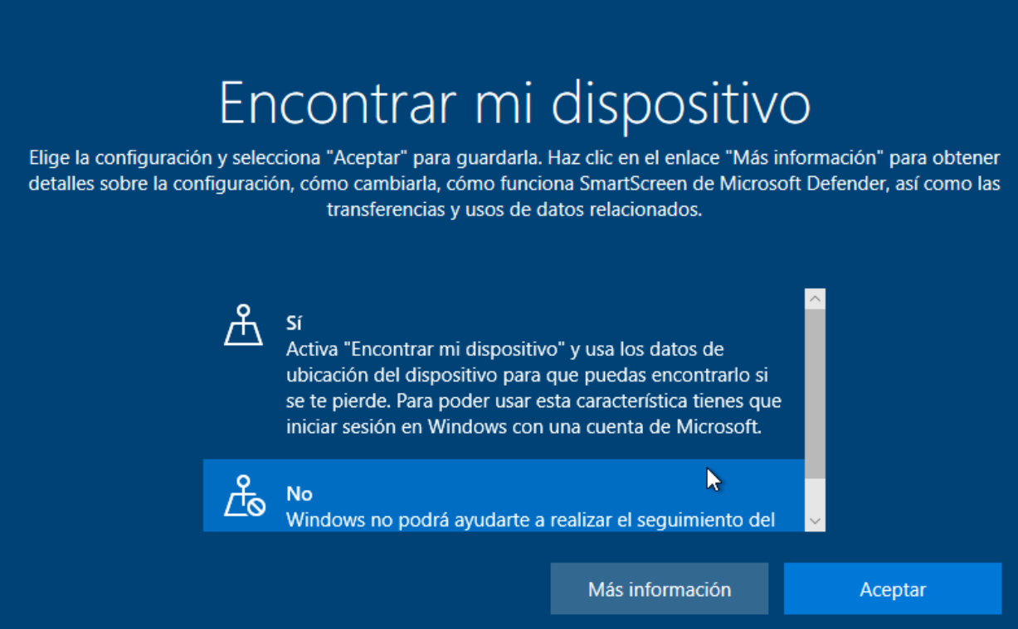

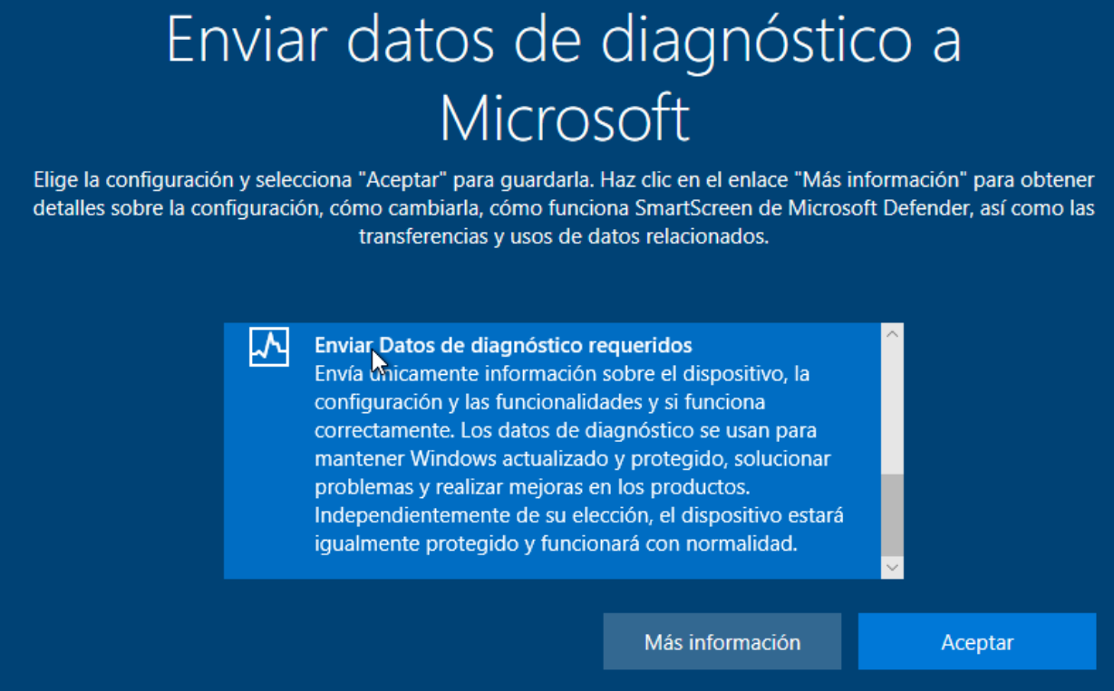

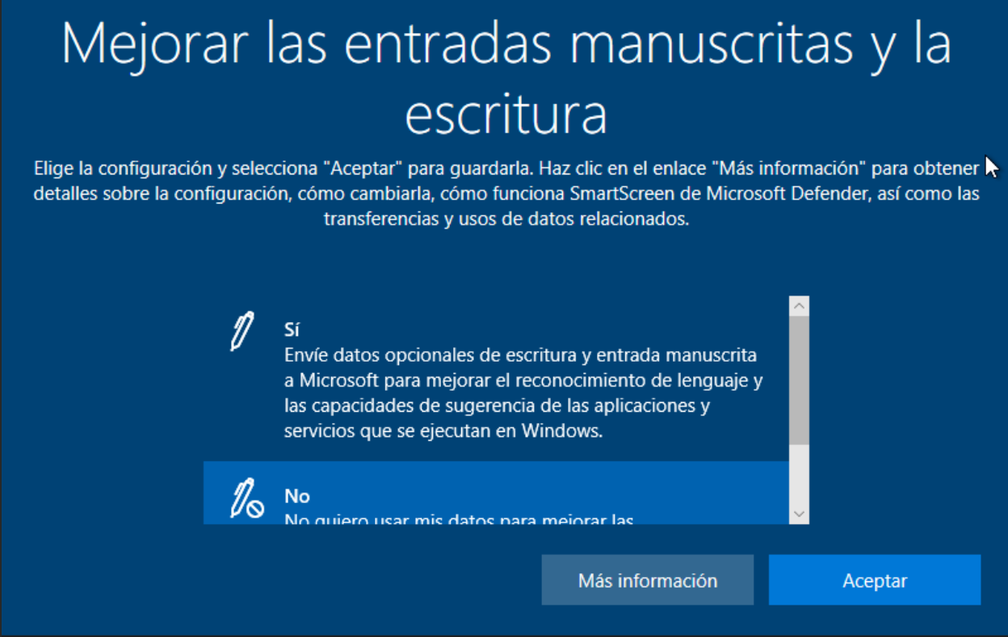

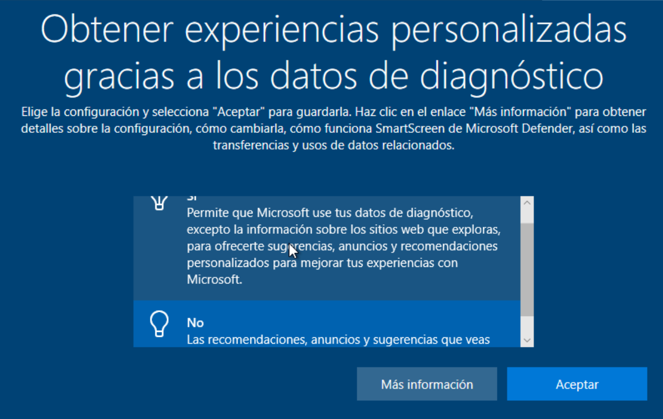

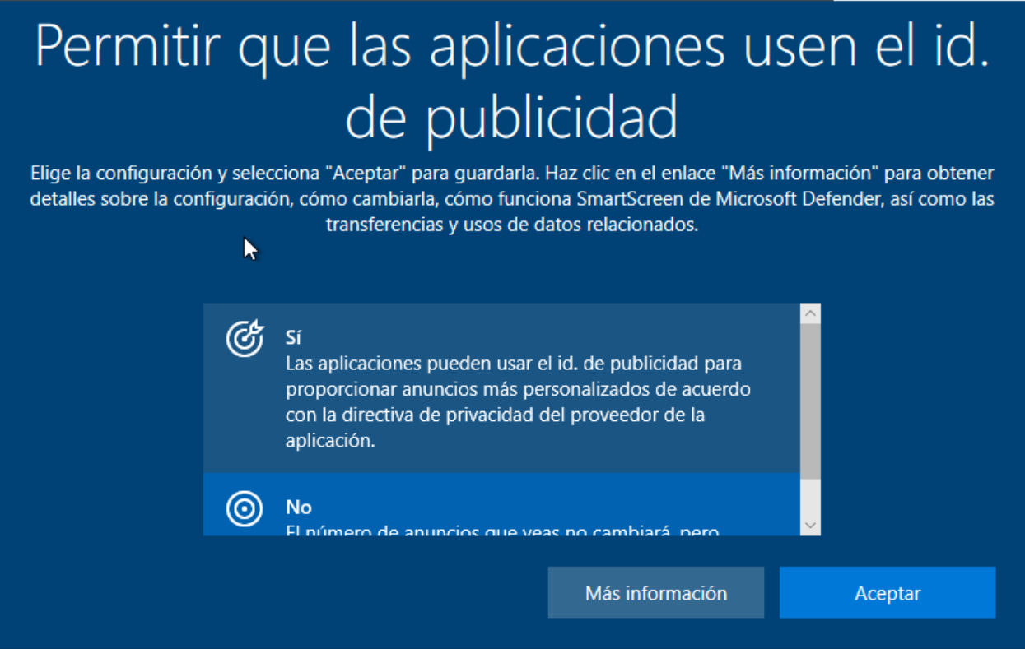



Here if you don't want cortana to bother you choose ahora no

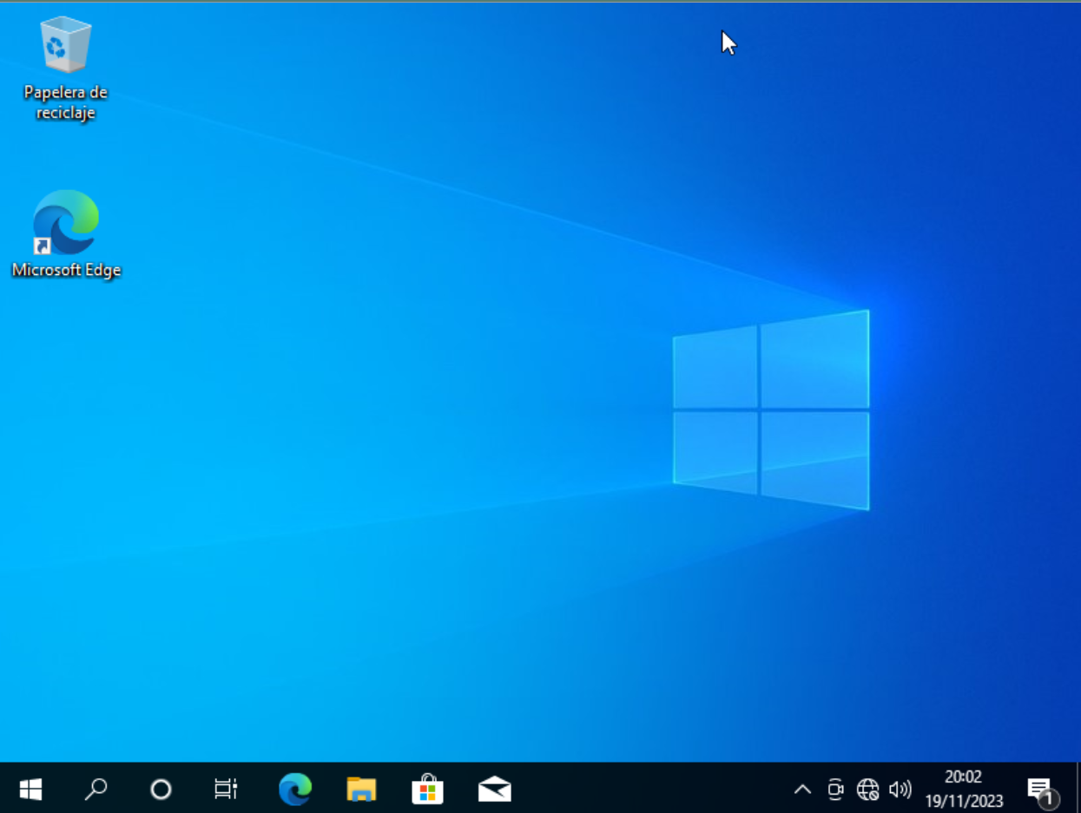

Now we have to install de the net driver

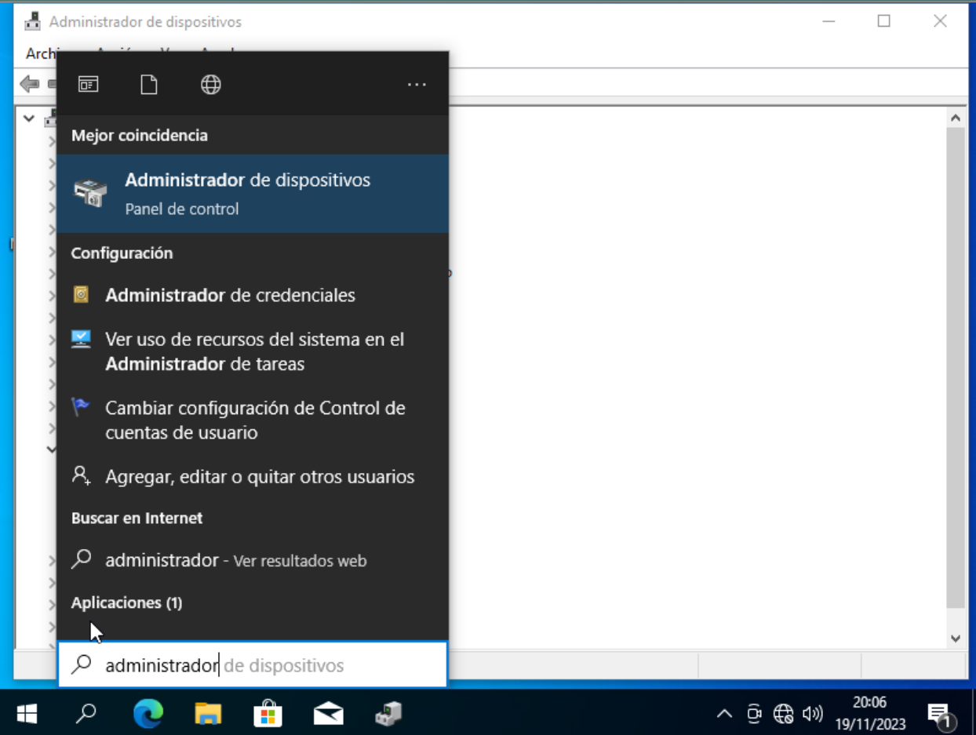

We use the windows menu and search for administrador de dispositivos

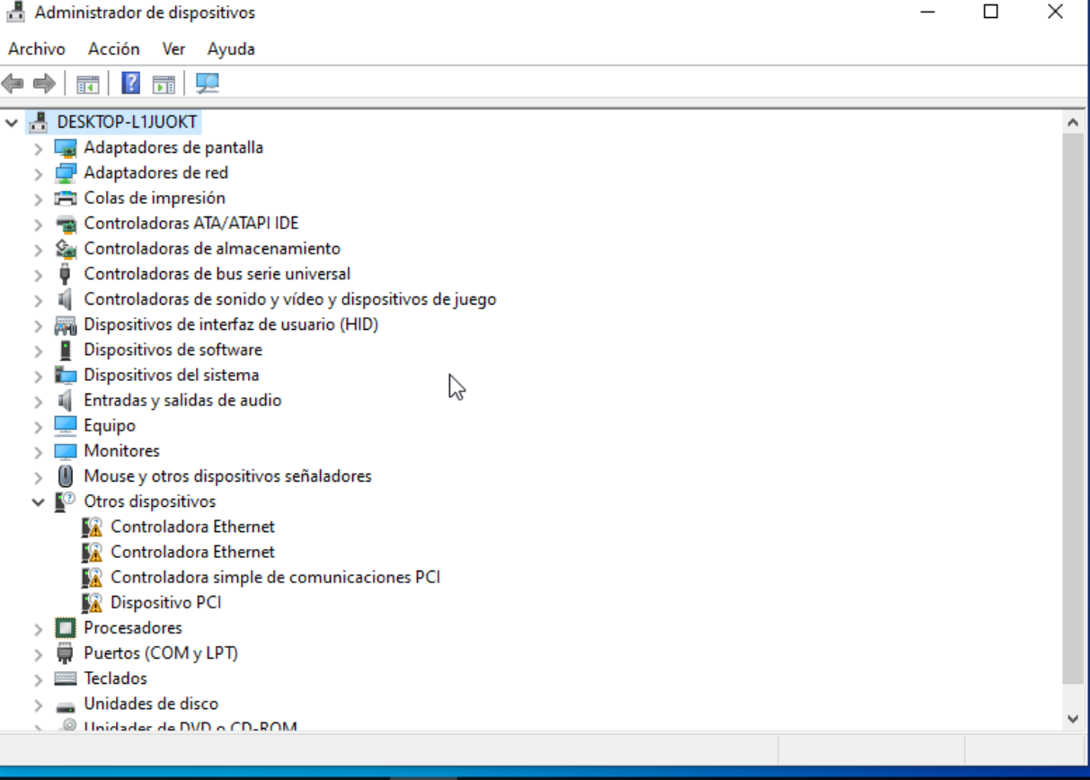

Right click on controladora ethernet

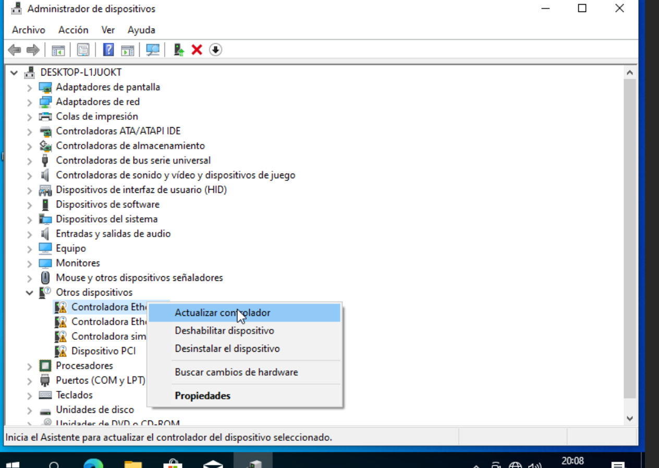

Click on actualizar controlador

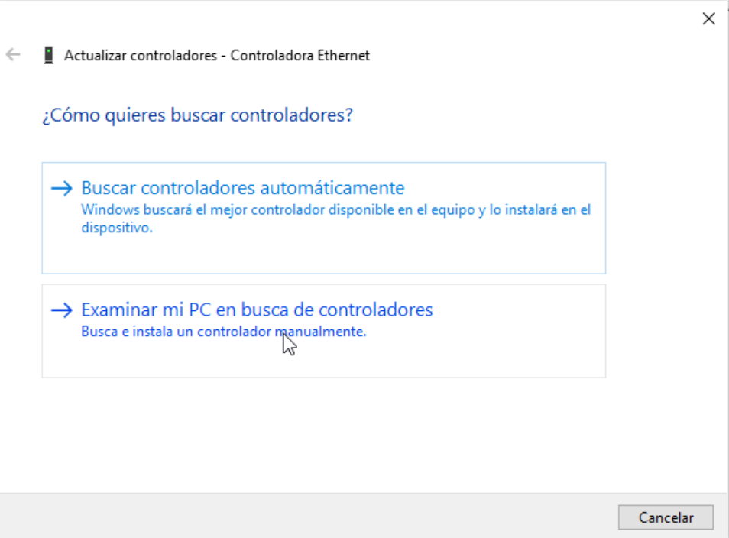

Click on examinar mi PC

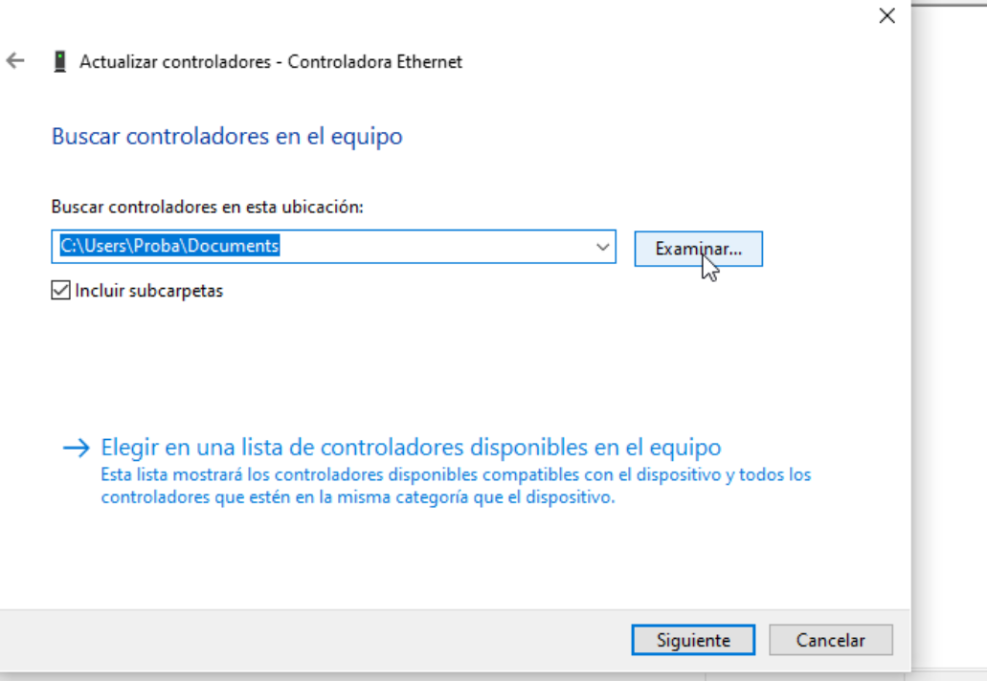

Click on the examinar button

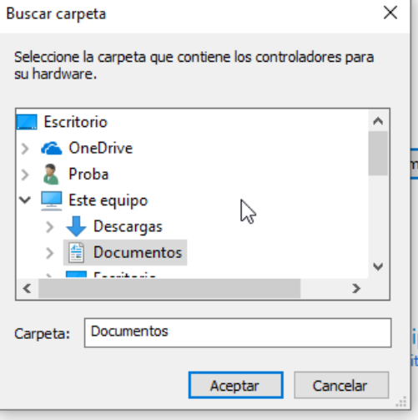

Search for this

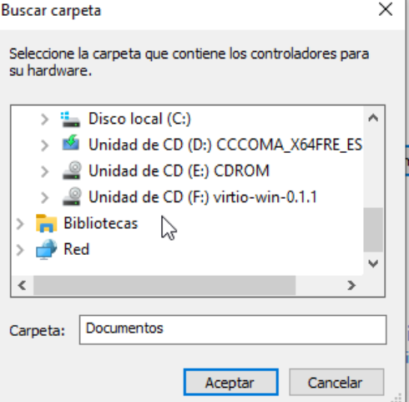

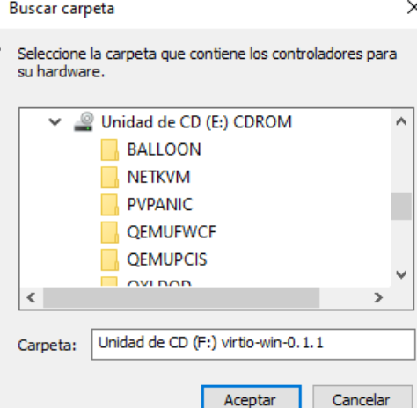

Click on NETKVM and then instalar

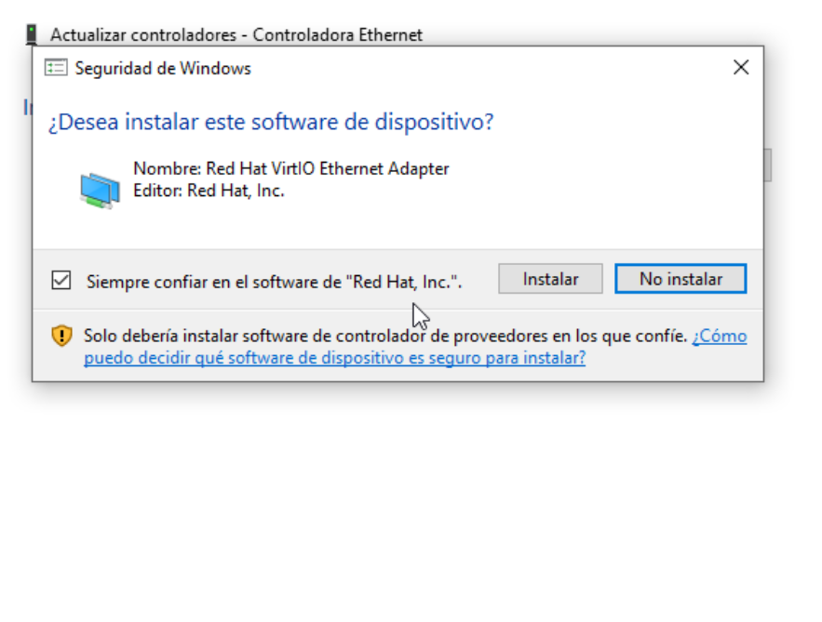

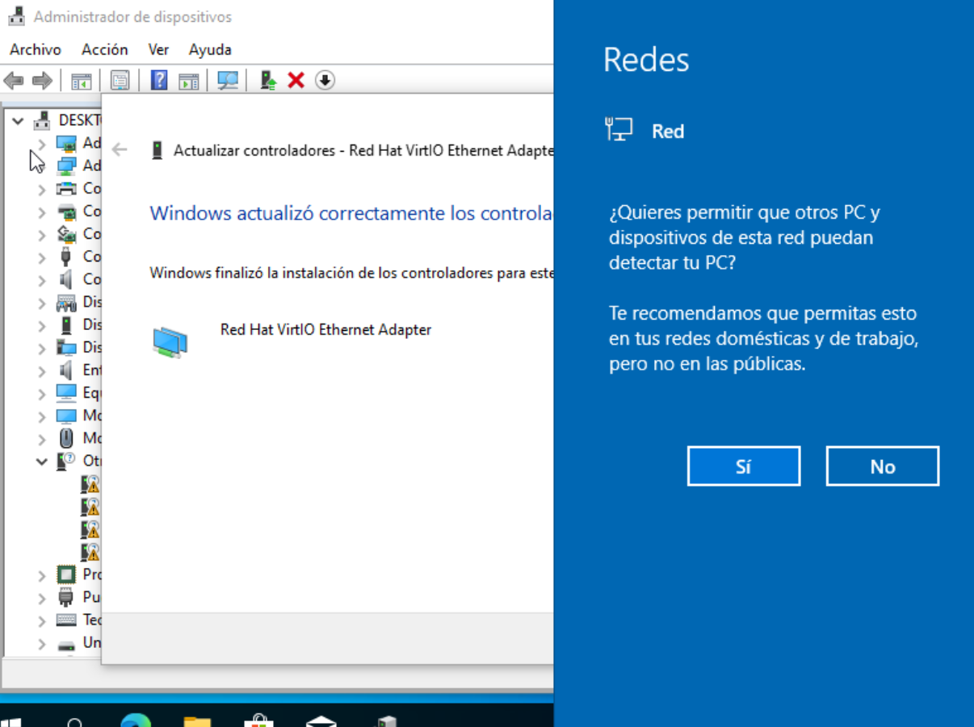

Click si

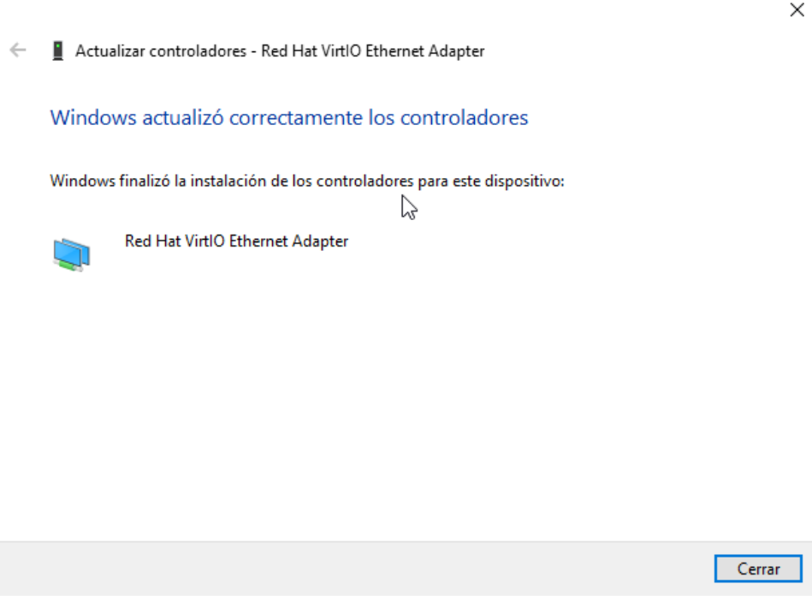

Click cerrar

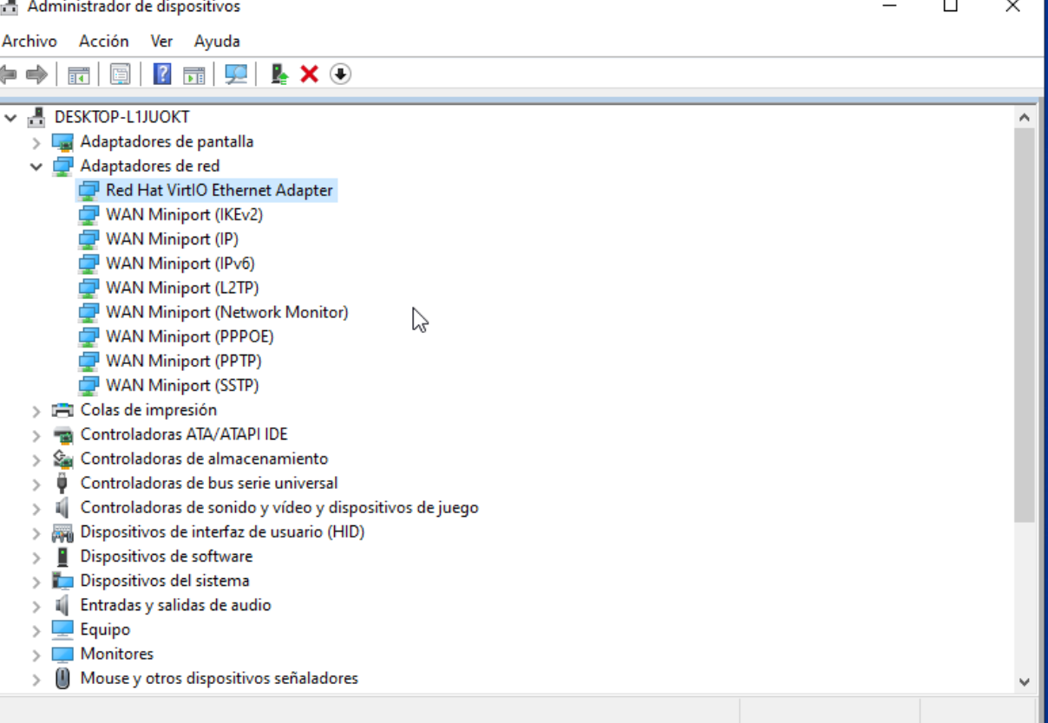

Now for the shared folder we need to give our pc an IP address

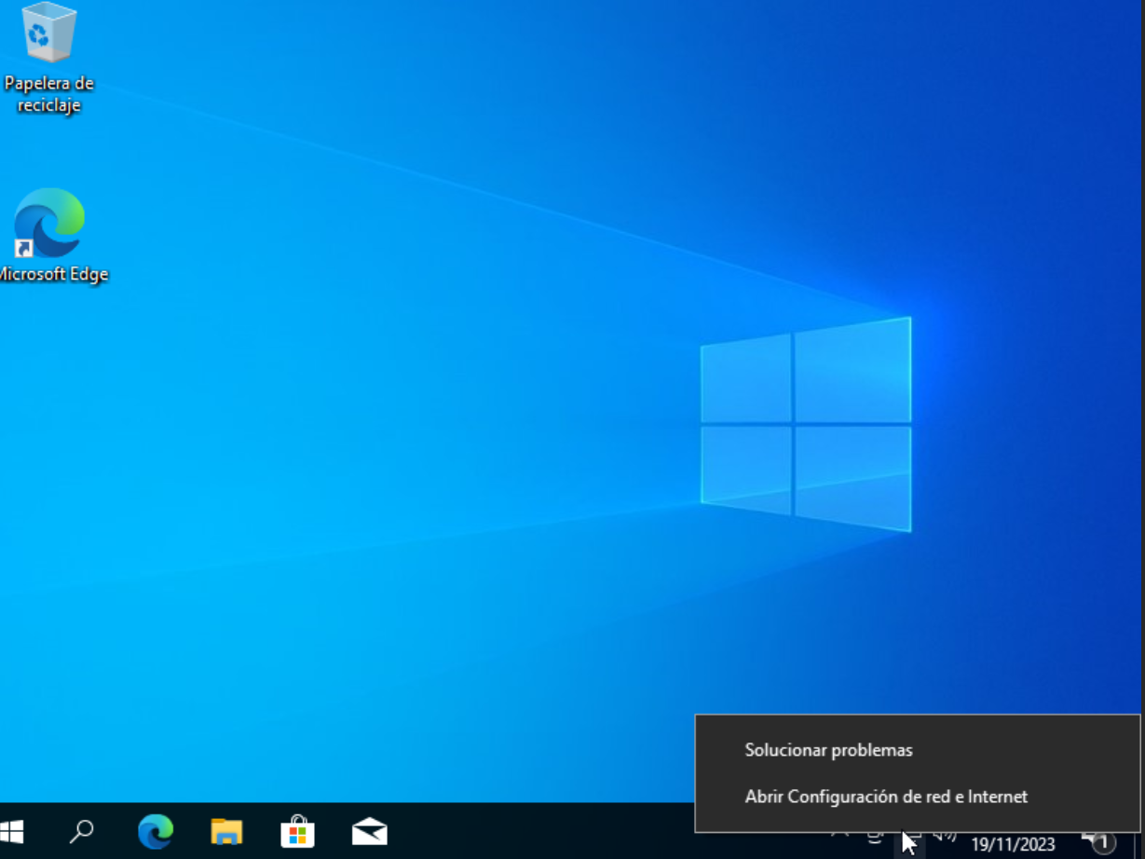

Right click on the net icon and then click abrir configuración

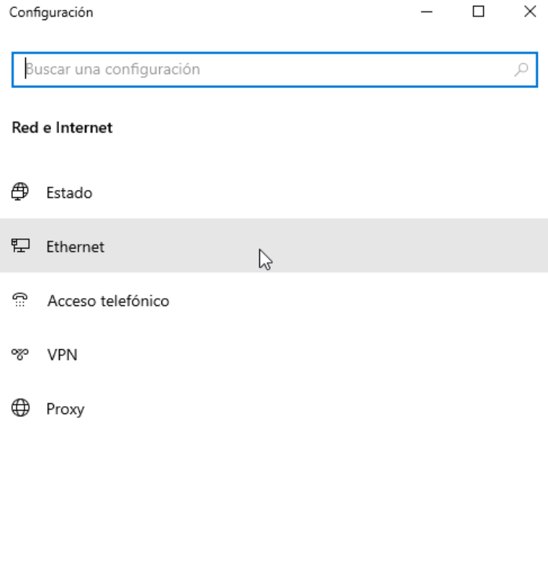

Click there

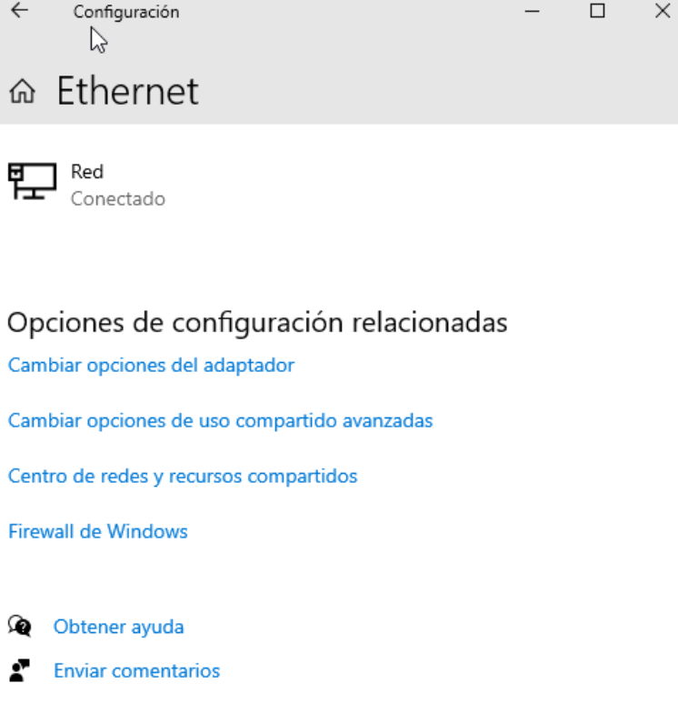

Click opciones del adaptador

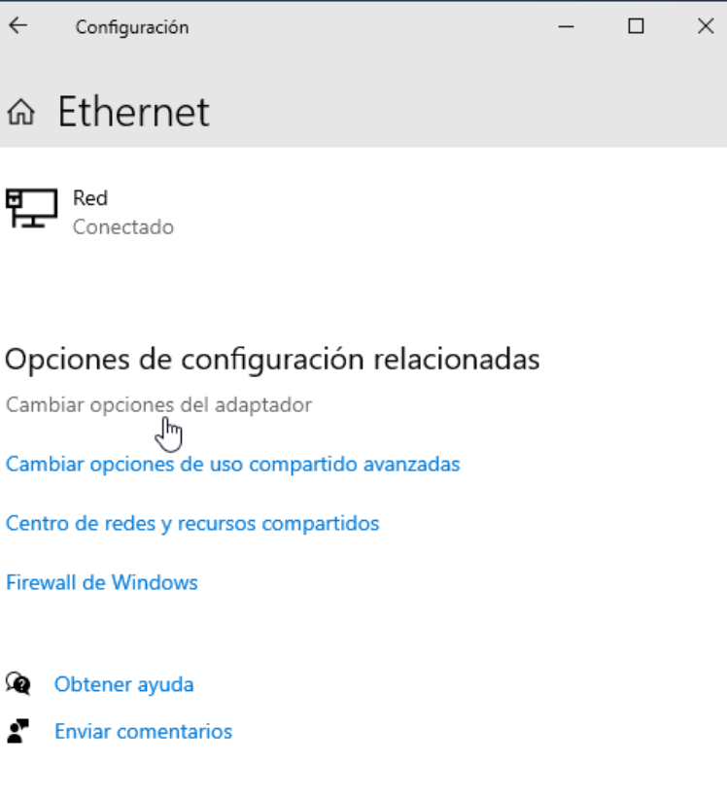

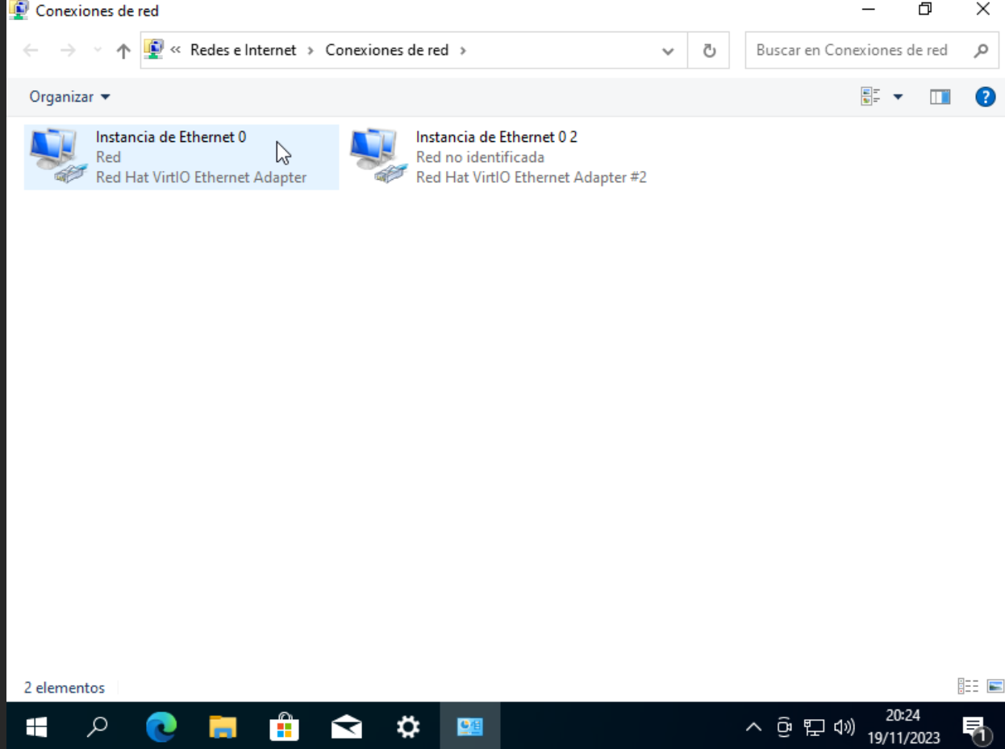

Right click on the second one

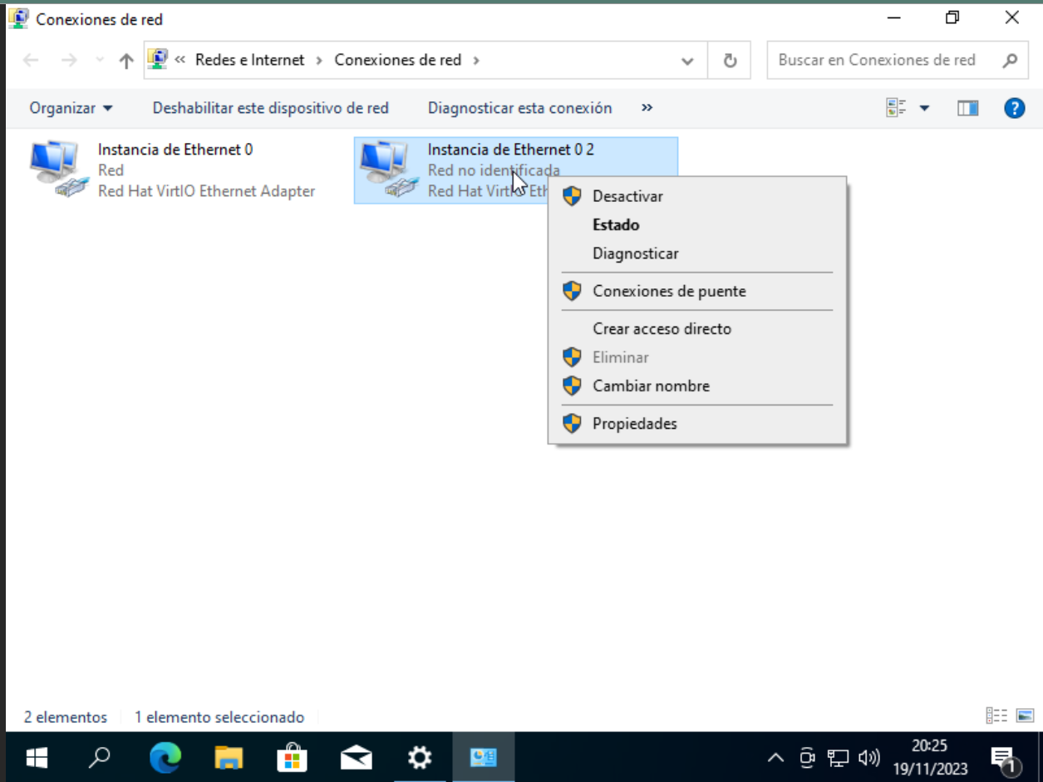

Click on propiedades

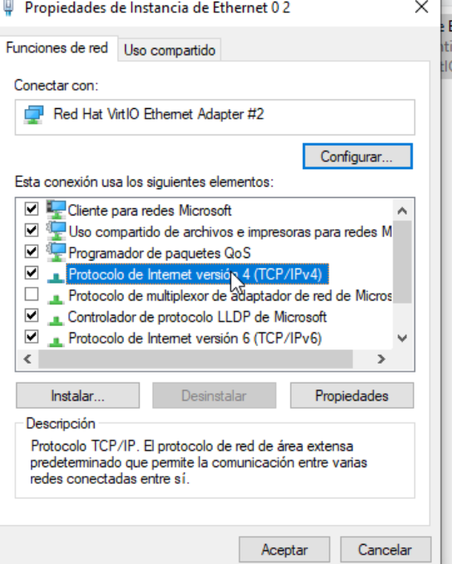

Click on that option and then propiedades

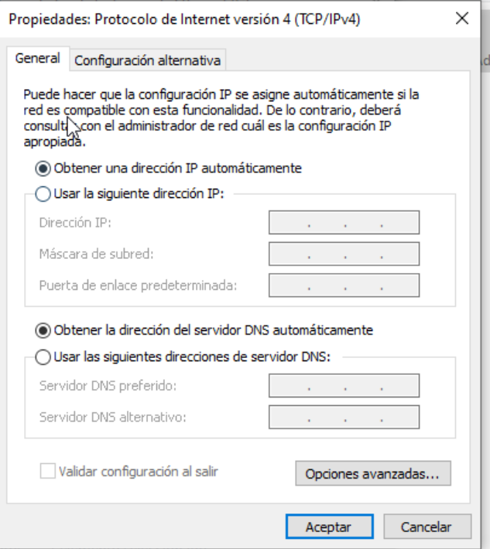

Here we choose an IP that is in our net, this for example

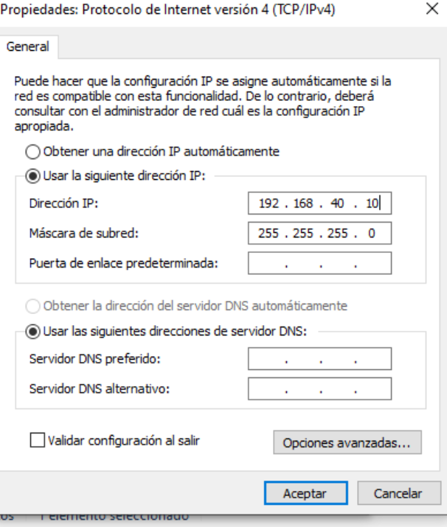

Now we made an user in our machine that is the same as the user who have to access the folder

Again we have to search in the windows menu

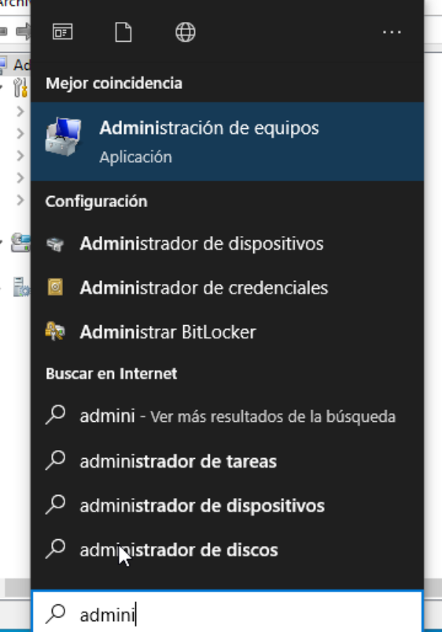

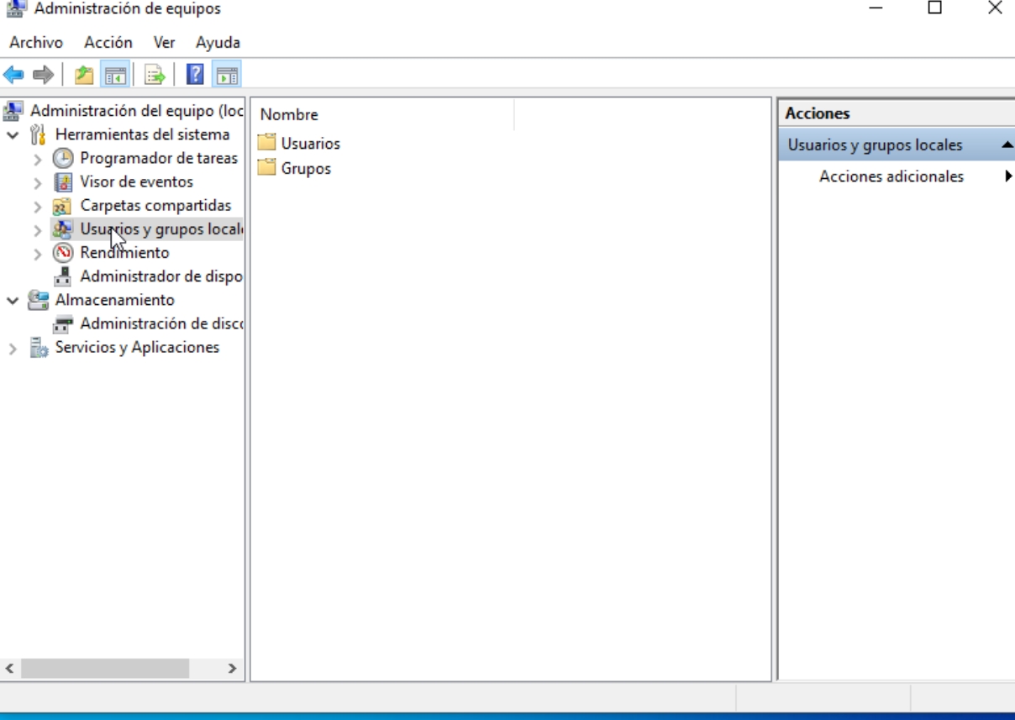

We go to users

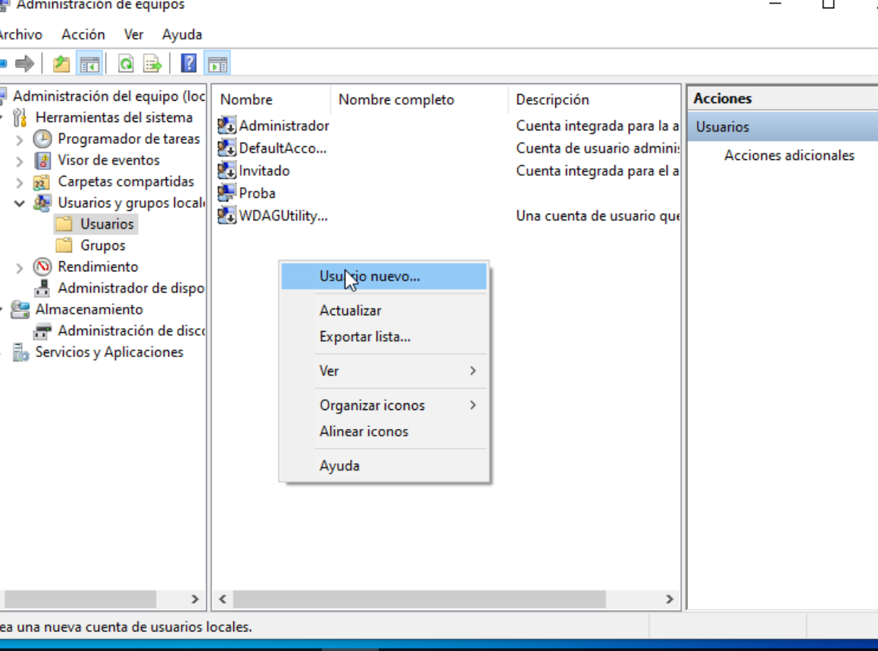

In users we right click and choose usuario nuevo

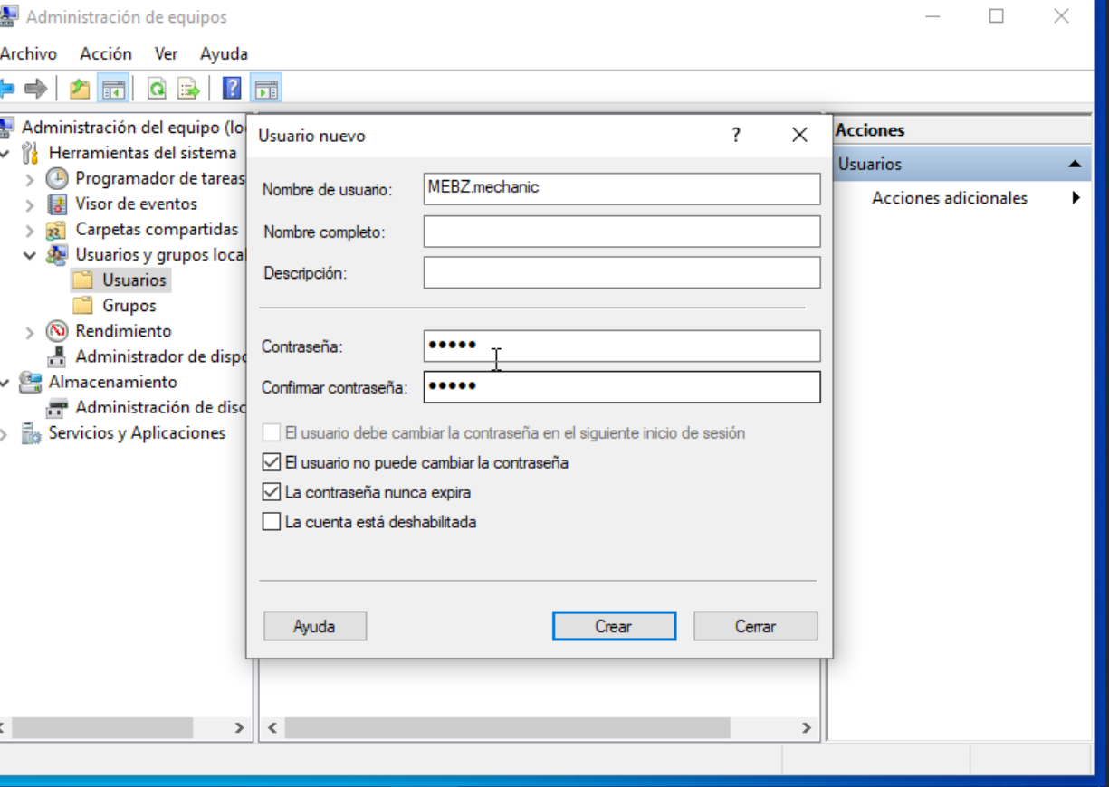

We enter the username and the password then we press crear and then cerrar

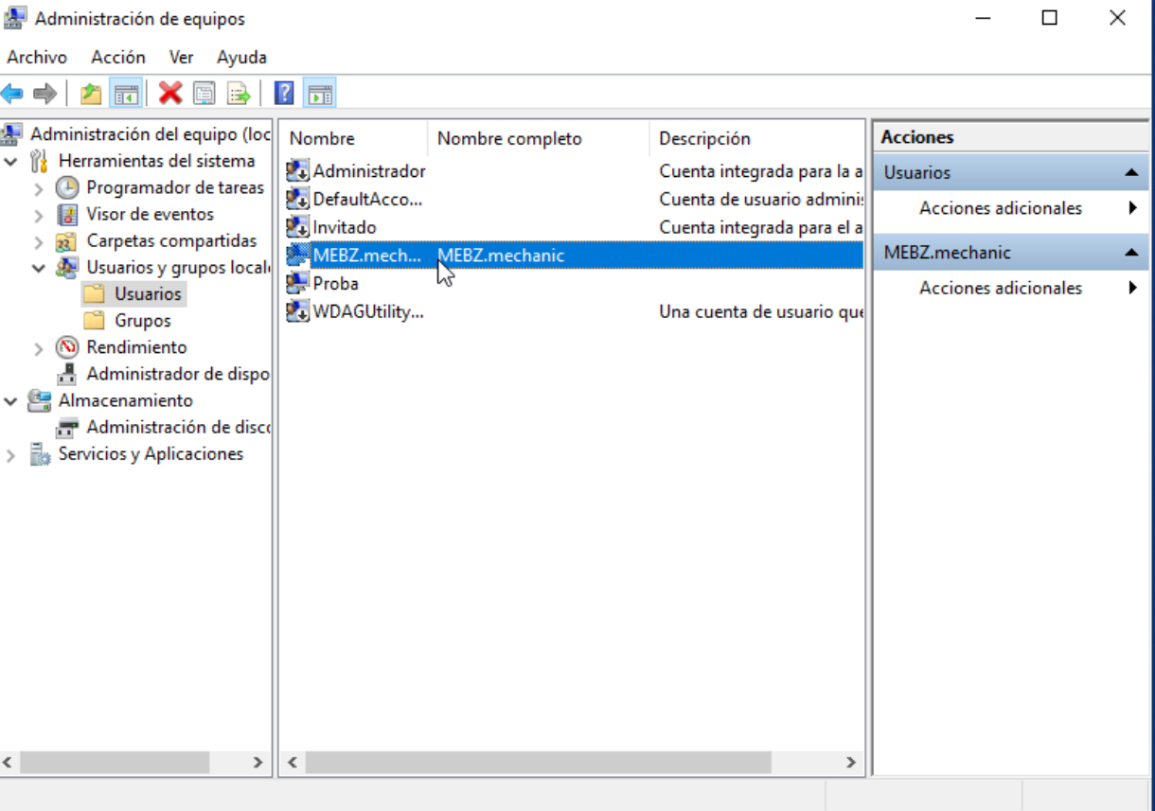

Now we make the folder and for that we choose the place where we create the folder

For example disco local c

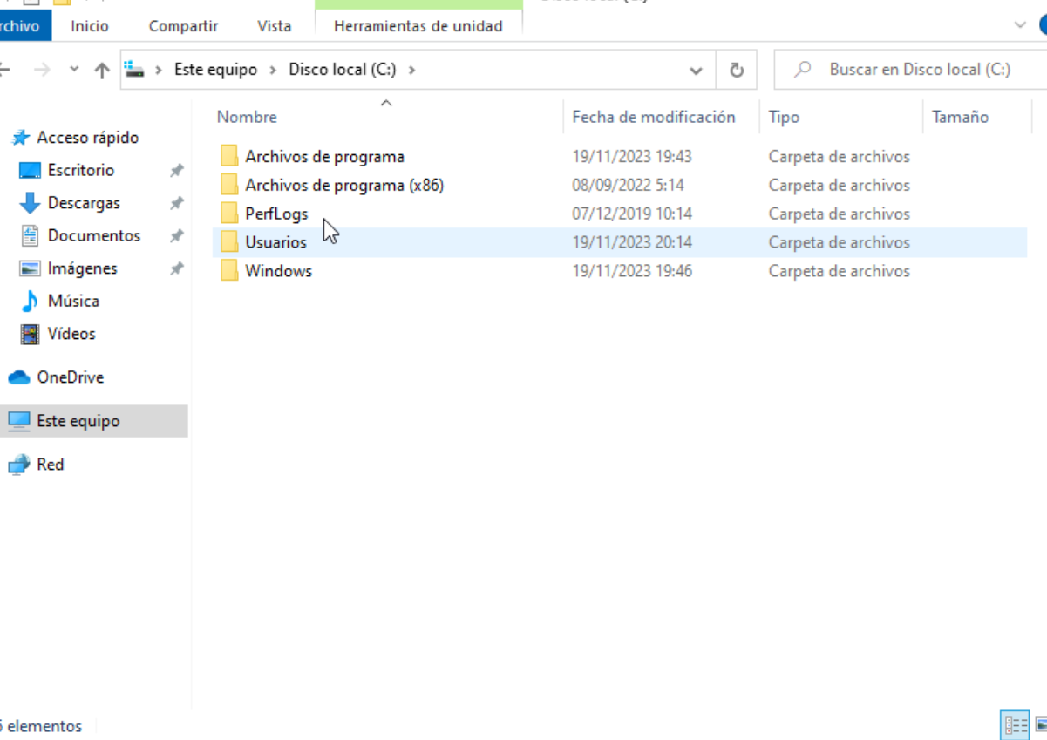

Right click

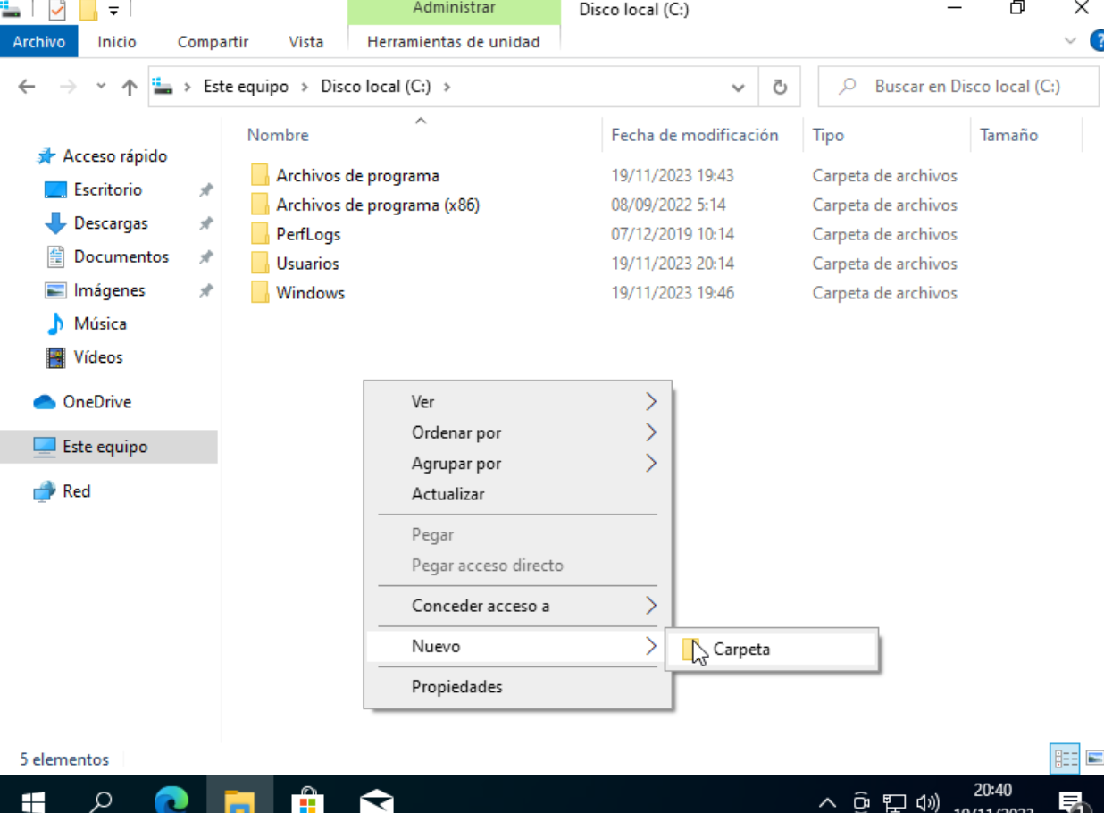

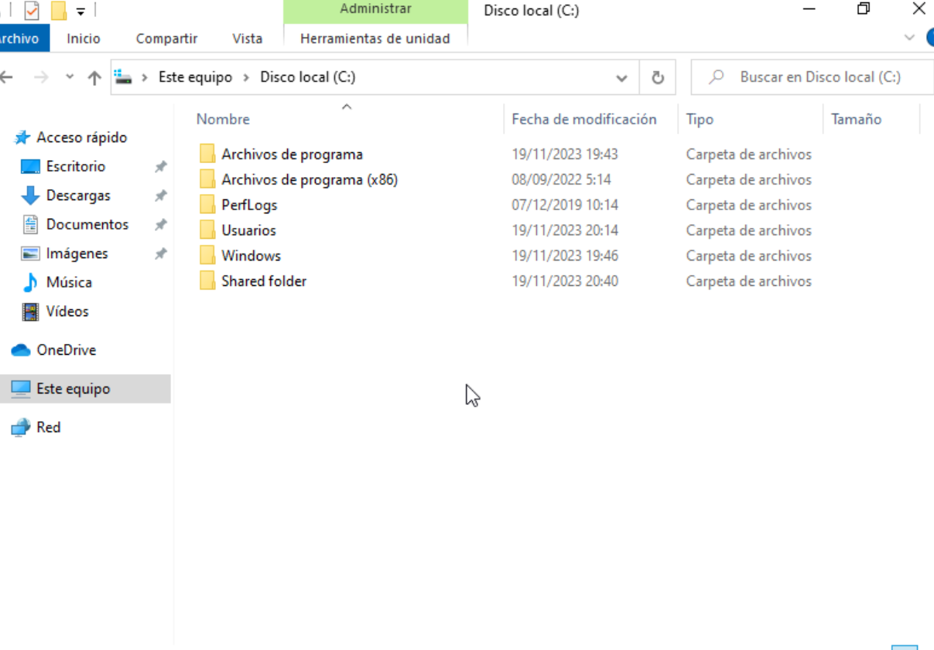

Right click on the folder and click propiedades

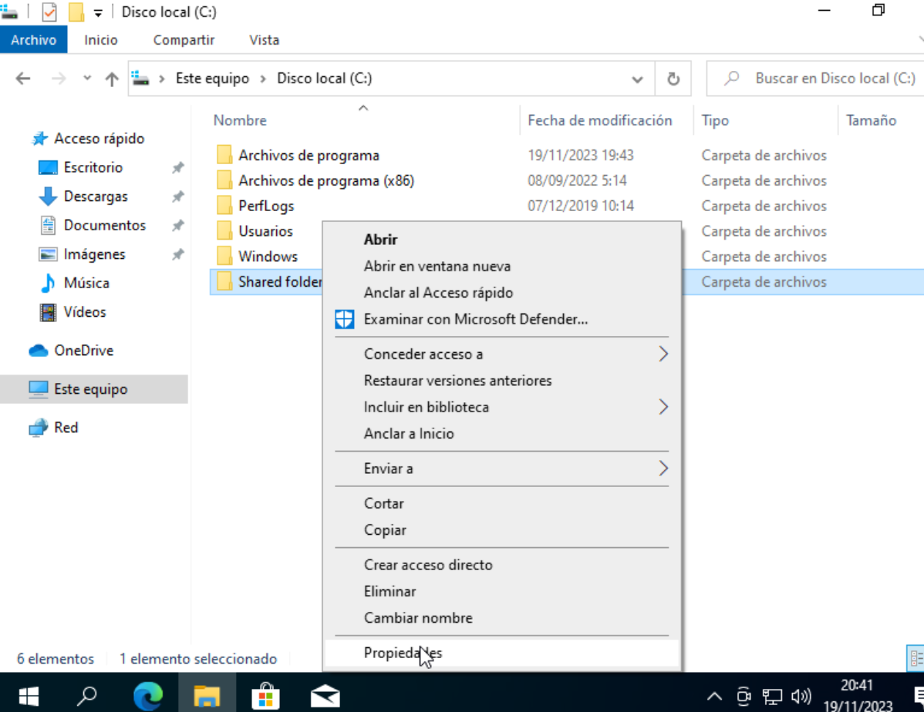

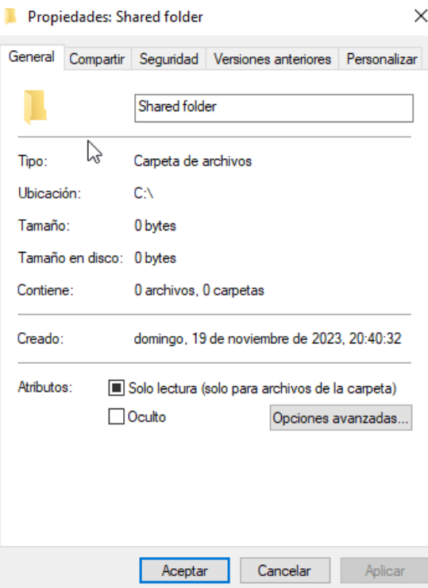

Click on compartir

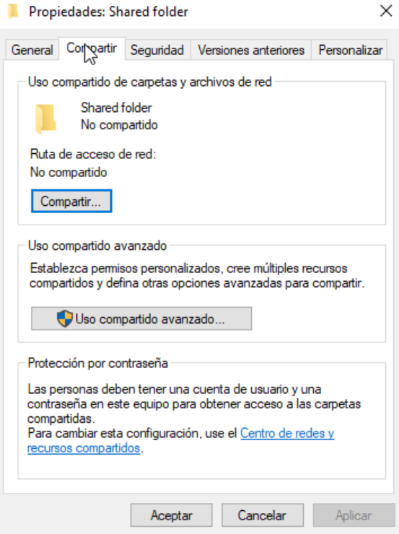

Click on Compartir….

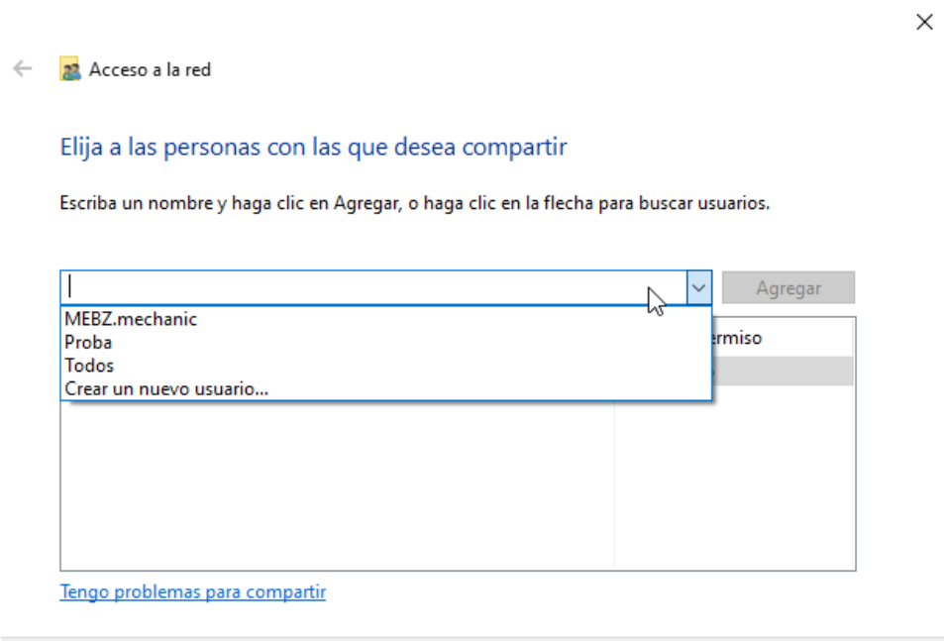

Choose the user

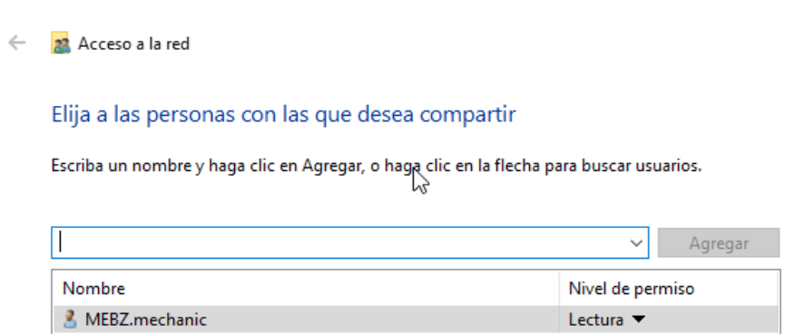

Click on compartir

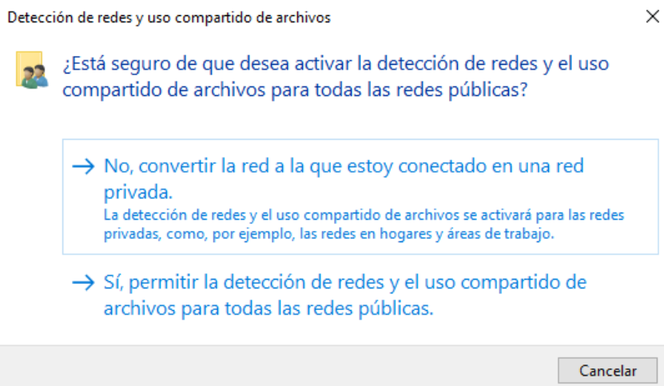

Click yes

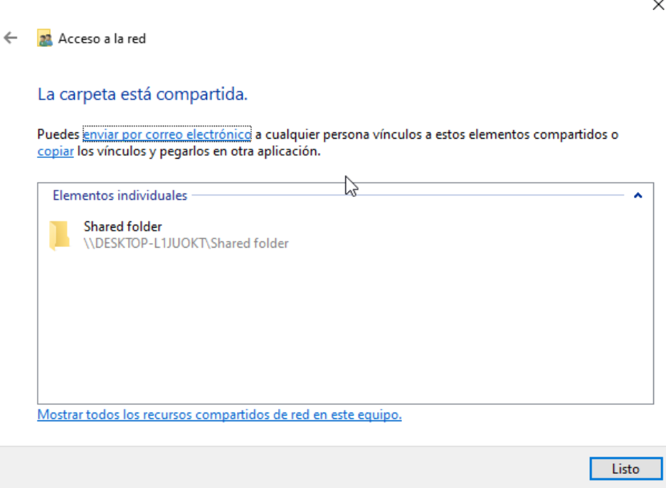

Click listo and now enter we the machine you have shared the folder but don't close the one that is sharing

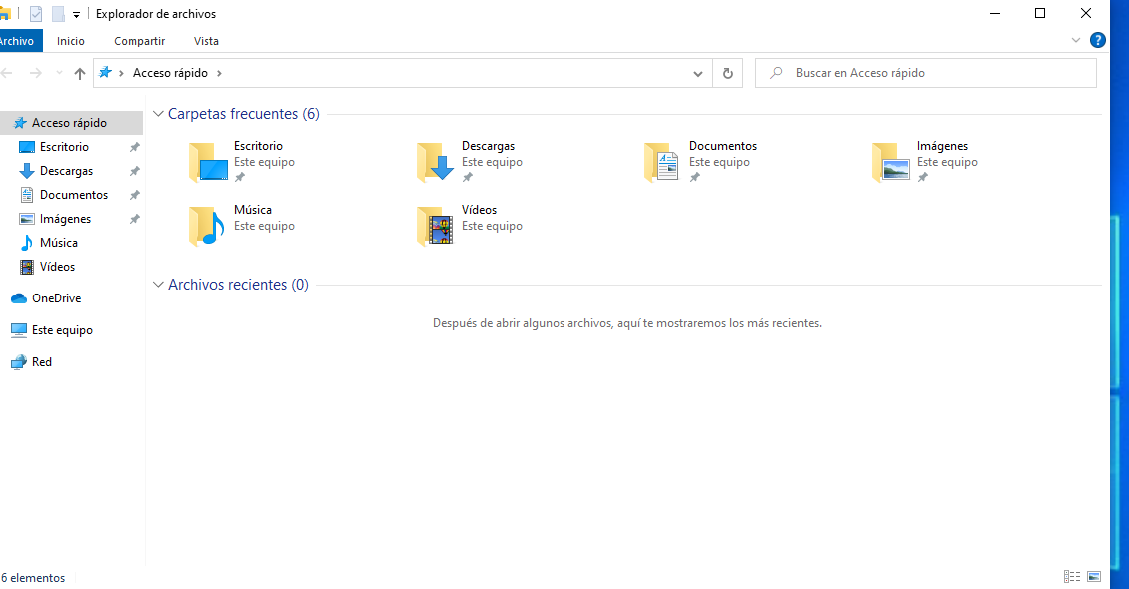

Click on red and in this browser search for the pc it can be the name or the IP

